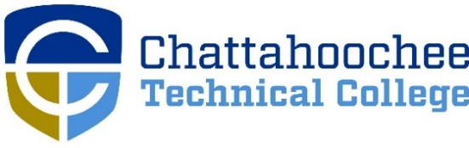

POSITION ANNOUNCEMENT

POSITION: Anatomy and Physiology(A&P) (Part-time, North Metro Campus/Online)

POSITION DESCRIPTION: Under the supervision of the Director of Academic Success, tutors will assist students in A&P both in person and virtually through the use of Microsoft Teams. Applicants will be reviewed each semester for potential start the following semester. Success Centers are located at the Appalachian, Canton, Marietta, Mountain View, North Metro, Paulding, and Woodstock campuses. This position will operate during normal business hours for the North Metro Academic Success Center.

MINIMUM QUALIFICATIONS:
- Associate Degree in discipline area, or closely related field
- Experience as a tutor or teacher
- Good communication skills
- Excellent customer service skills

PREFERRED QUALIFICATIONS:
- Bachelor Degree in discipline area, or closely related field

SALARY/BENEFITS
- Salary is $15.00 per hour.
- There are no State Benefits. Please be aware that all Chattahoochee Technical College employees must be paid by DIRECT DEPOSIT unless exempted by the State Accounting Office based on “hardship” evidence provided by the employee.

TELEWORK: This position is authorized to telework up to 30% of a nineteen-hour work week with supervisor approval.

RESPONSE DEADLINE: Until Filled
APPLICATION PROCEDURE: APPLY ONLINE ONLY at www.chattahoocheetech.edu and select “Contact Us” then “Jobs and Careers at CTC.” For a complete file, fill out an online application, upload cover letter, resume, and transcripts and include three professional references’ contact information. Before a candidate is hired, a pre-employment criminal background investigation and employer/professional reference check will be conducted. Following screening, candidates may be asked to submit further documentation. If conditional offer of employment is made, applicant may be subject to drug and/or alcohol testing appropriate to the position.

RESPONSE DEADLINE: Until filled

EMPLOYMENT POLICY: Chattahoochee Technical College is accredited by the Southern Association of Colleges and Schools Commission on Colleges (SACSCOC) to award associate degrees, diplomas, and certificates. Questions about the accreditation of Chattahoochee Technical College may be directed in writing to the Southern Association of Colleges and Schools Commission on Colleges at 1866 Southern Lane, Decatur, GA 30033-4097, by calling (404) 679-4500, or by using information available on SACSCOC’s website (www.sacscoc.org). As set forth in its student catalog, Chattahoochee Technical College does not discriminate on the basis of race, color, creed, national or ethnic origin, gender, religion, disability, age, political affiliation or belief, genetic information, veteran status, or citizenship status (except in those special circumstances permitted or mandated by law). The following person(s) has been designated to handle inquiries regarding the non-discrimination policies: Chattahoochee Technical College Title IX Coordinator, Shanequa Warrington, 980 S Cobb Drive, C 1102B, Marietta, GA 30060, 770-975-4023, Shanequa.Warrington@chattahoocheetech.edu and Chattahoochee Technical College Section 504 Coordinator, Caitlin Barton, 5198 Ross Road, Building A1320, Acworth, GA 30102, (770) 975-4099, or Caitlin.Barton@chattahoocheetech.edu.

A unit of the Georgia Department of Technical and Adult Education

