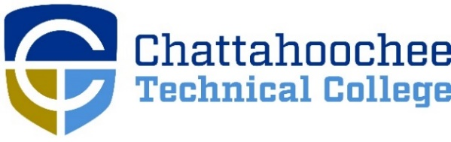

POSITION ANNOUNCEMENT

POSITION: CNA Program Adjunct Instructor (Dual Enrollment)

POSITION DESCRIPTION: Part-time position available for Certified Nursing Assistant Program Adjunct faculty. Responsibilities are centered on preparing and teaching the Dual Enrollment Certified Nursing Assistant classes in High Schools that have partnered with Chattahoochee Tech. Classes are scheduled according to the needs of the individual High School. This will also include responsibilities for the clinical requirements of the class. There are positions available in Bartow, Cherokee, Cobb, Gilmer, Paulding, and Pickens counties.
“NOTE: Adjunct faculty positions are temporary, part time positions of employment appointed on a per academic term basis.”

MINIMUM QUALIFICATIONS:
- Licensed Practical Nurse (with at least one year of nursing home experience) or Registered Nurse. Both are required to have a current valid Georgia nursing license
- Strong interpersonal, communication and computer literacy skills
- Experience in field

PREFERRED QUALIFICATIONS:
- Experience in classroom teaching
- Train – the – Trainer for CNA certificate from GMCF
- Experience using an online learning management system such as Blackboard Learning

SALARY/BENEFITS: Salary dependent on course taught. There are no State Benefits.

APPLICATION PROCEDURE: APPLY ONLINE ONLY @ www.chattahoocheetech.edu and select “Quick Links” then “Jobs & Career.” Fill out an online application and upload resume, and required licensure and certification documents. Before a candidate is hired, a pre-employment criminal background investigation and employer/professional reference check will be conducted. Following screening, candidates may be asked to submit further documentation, including official college transcripts. Please be aware that all Chattahoochee Technical College employees must be paid by DIRECT DEPOSIT unless exempted by the State Accounting Office based on “hardship” evidence provided by the employee.

RESPONSE DEADLINE: Opened until filled

ANTICIPATED EMPLOYMENT DATE: Beginning of semester

EMPLOYMENT POLICY: Chattahoochee Technical College is accredited by the Southern Association of Colleges and Schools Commission on Colleges (SACSCOC) to award associate degrees, diplomas, and certificates. Questions about the accreditation of Chattahoochee Technical College may be directed in writing to the Southern Association of Colleges and Schools Commission on Colleges at 1866 Southern Lane, Decatur, GA 30033-4097, by calling (404) 679-4500, or by using information available on SACSCOC’s website (www.sacscoc.org). As set forth in its student catalog, Chattahoochee Technical College does not discriminate on the basis of race, color, creed, national or ethnic origin, gender, religion, disability, age, political affiliation or belief, genetic information, veteran status, or citizenship status (except in those special circumstances permitted or mandated by law). The following person(s) has been designated to handle inquiries regarding the non-discrimination policies: Chattahoochee Technical College Title IX Coordinator, Shanequa Warrington, 980 S Cobb Drive, C 1102B, Marietta, GA 30060, 770-975-4023, Shanequa.Warrington@chattahoocheetech.edu and Chattahoochee Technical College Section 504 Coordinator, Caitlin Barton, 5198 Ross Road, Building A1320, Acworth, GA 30102, (770) 975-4099, or Caitlin.Barton@chattahoocheetech.edu.

