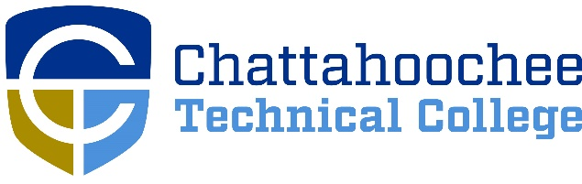

POSITION ANNOUNCEMENT

POSITION: Diesel Technology Tutor
Principal assignment: North Metro Campus

POSITION DESCRIPTION: Part-time position available as Tutor.
Part-time position based on semester system. Under supervision of the Technical Studies & Engineering Technologies Associate Dean and the Dean of Business and Technical Studies, the Tutor will be responsible for assisting students with their course and lab work. Assisting the Diesel Technology department in maintaining the lab set up/take down, ensuring lab safety requirements and any other duties as defined by The Technical College System of Georgia.
NOTE: Tutor positions are temporary, part time positions of employment appointed on a per academic term basis.

MINIMUM QUALIFICATIONS:
- Educational Level: This position requires completion of the following Diesel Equipment Technology courses with a grade of C or higher - DIET 1000 and 1010
- Knowledge of the following areas: Diesel electrical and electronic systems used on medium/heavy duty trucks and heavy equipment. Diesel preventive maintenance procedures pertaining to medium/heavy duty trucks and heavy equipment. Lab Safety procedures
- Applicant must meet the minimum requirements before scheduling an interview.
- Applicant is responsible for ensuring official/unofficial transcripts are on EZHr.

PREFERRED QUALIFICATIONS:
- A preference is given to applicants having a Diploma in a related field.
- Two years industry experience in diesel equipment field and/or relevant certifications are preferred.

SALARY/BENEFITS: Salary based on 15.00 per hour. There are no State Benefits. Please be aware that all Chattahoochee Technical College employees must be paid by DIRECT DEPOSIT unless exempted by the State Accounting Office based on “hardship” evidence provided by the employee.

APPLICATION PROCEDURE: APPLY ONLINE ONLY @ www.chattahoocheetech.edu and select “me@CTC” then “Jobs and Careers at CTC.” Fill out an online application and upload resume, cover letter, and related licenses/certificates. Before a candidate is hired, a pre-employment criminal background investigation and employer/professional reference check will be conducted. Following screening, candidates may be asked to submit further documentation, including official college transcripts.

RESPONSE DEADLINE: Opened until filled

ANTICIPATED EMPLOYMENT DATE: Open ended

EMPLOYMENT POLICY: Chattahoochee Technical College is accredited by the Southern Association of Colleges and Schools Commission on Colleges (SACSCOC) to award associate degrees, diplomas, and certificates. Questions about the accreditation of Chattahoochee Technical College may be directed in writing to the Southern Association of Colleges and Schools Commission on Colleges at 1866 Southern Lane, Decatur, GA 30033-4097, by calling (404) 679-4500, or by using information available on SACSCOC’s website (www.sacscoc.org). As set forth in its student catalog, Chattahoochee Technical College does not discriminate on the basis of race, color, creed, national or ethnic origin, gender, religion, disability, age, political affiliation or belief, genetic information, veteran status, or citizenship status (except in those special circumstances permitted or mandated by law). The following person(s) has been designated to handle inquiries regarding the non-discrimination policies: Chattahoochee Technical College Title IX Coordinator, Shanequa Warrington, 980 S Cobb Drive, C 1102B, Marietta, GA 30060, 770-975-4023, Shanequa.Warrington@chattahoocheetech.edu and Chattahoochee Technical College Section 504 Coordinator, Caitlin Barton, 5198 Ross Road, Building A1320, Acworth, GA 30102, (770) 975-4099, or Caitlin.Barton@chattahoocheetech.edu.

A unit of the Georgia Department of Technical and Adult Education

