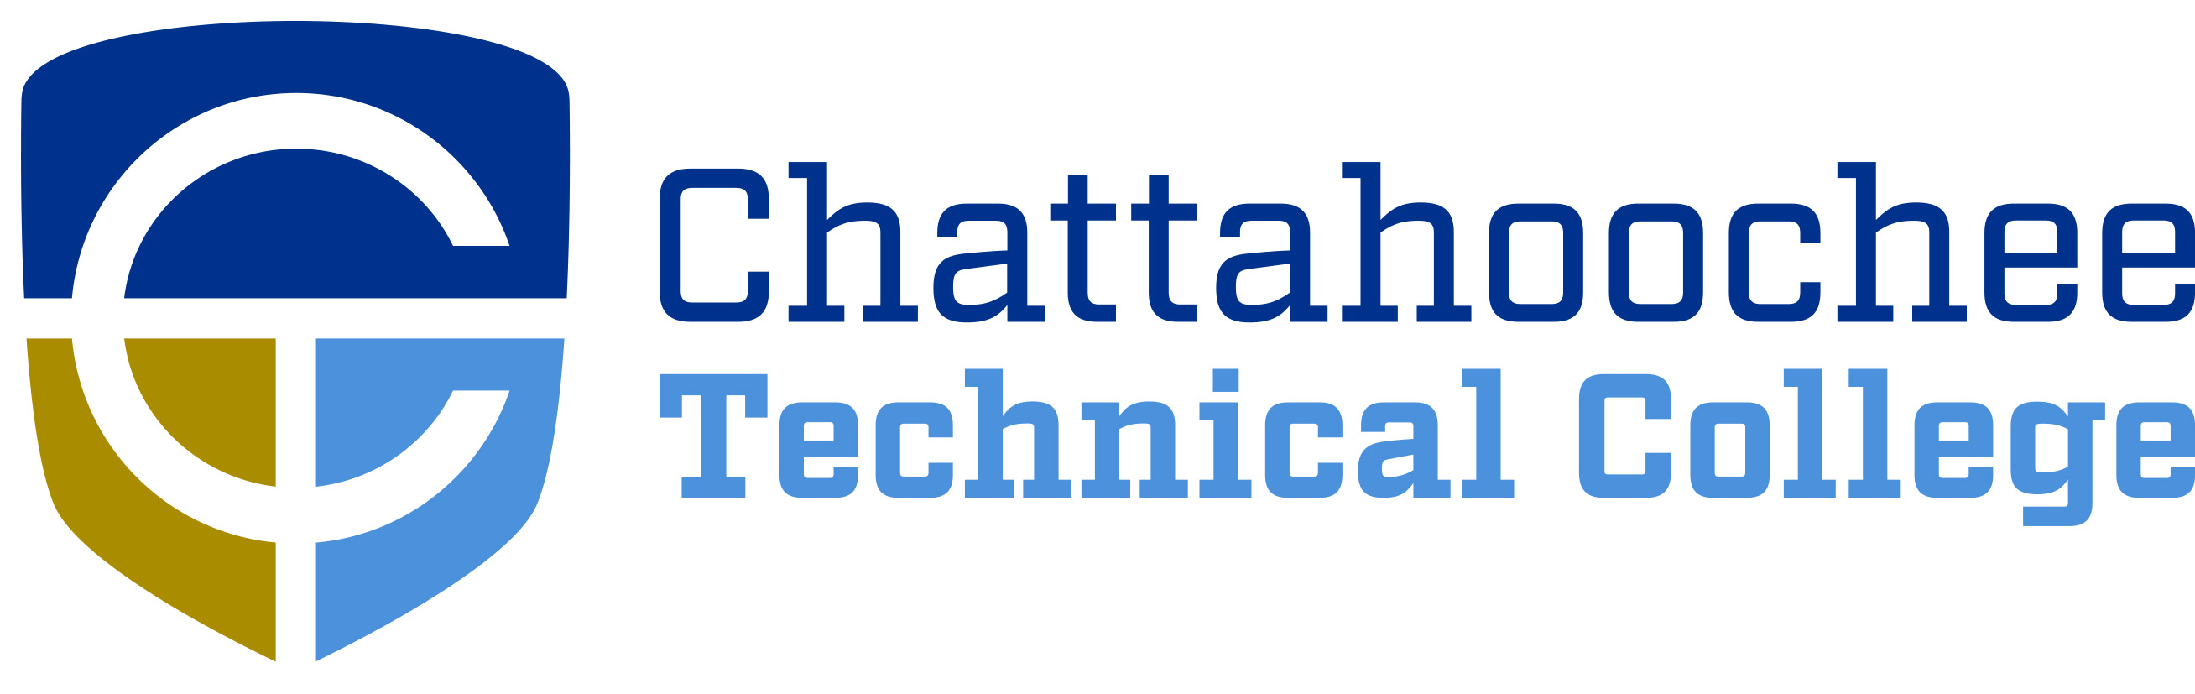

POSITION ANNOUNCEMENT

POSITION: Medical Assisting Adjunct Instructor (non-credit)

POSITION DESCRIPTION: The Medical Assisting Adjunct position will be on an as needed basis for the Economic Development division to teach a non-credit Medical Assisting program located on the Marietta Campus. The program will be a hybrid format with on-campus courses conducted two evenings a week or one day per week over a 3-4-month period for each cohort. The online component will utilize the NHA training curriculum and Blackboard.

MINIMUM QUALIFICATIONS:
- Holds Diploma, Associate Degree, or Higher in the Allied Health Field.
- Current CMA Certification
- Strong interpersonal, communication, and computer literacy skills
- 2+ years’ experience working in medical field

PREFERRED QUALIFICATIONS:
- Current CCMA Certification through the National Healthcare Association
- Experience as an instructor in medical related program
- Bachelor’s Degree in education, nursing, or another medical related field

SALARY/BENEFITS: Pay is dependent on the course taught, there are no State Benefits.

APPLICATION PROCEDURE: APPLY ONLINE ONLY. For a complete file fill out an online application, upload cover letter, resume, and transcripts (transcripts can be unofficial at this time). Before a candidate is hired, a pre-employment criminal background investigation and employer/professional reference check will be conducted. Following screening, candidates may be asked to submit further documentation.

RESPONSE DEADLINE: Until filled

ANTICIPATED EMPLOYMENT DATE: January/February 2023

EMPLOYMENT POLICY: Chattahoochee Technical College is accredited by the Southern Association of Colleges and Schools Commission on Colleges (SACSCOC) to award associate degrees, diplomas, and certificates. Questions about the accreditation of Chattahoochee Technical College may be directed in writing to the Southern Association of Colleges and Schools Commission on Colleges at 1866 Southern Lane, Decatur, GA 30033-4097, by calling (404) 679-4500, or by using information available on SACSCOC’s website (www.sacscoc.org). As set forth in its student catalog, Chattahoochee Technical College does not discriminate on the basis of race, color, creed, national or ethnic origin, gender, religion, disability, age, political affiliation or belief, genetic information, veteran status, or citizenship status (except in those special circumstances permitted or mandated by law). The following person(s) has been designated to handle inquiries regarding the non-discrimination policies: Chattahoochee Technical College Title IX Coordinator, Shanequa Warrington, 980 S Cobb Drive, C 1102B, Marietta, GA 30060, 770-975-4023, Shanequa.Warrington@chattahoocheetech.edu and Chattahoochee Technical College Section 504 Coordinator, Caitlin Barton, 5198 Ross Road, Building A1320, Acworth, GA 30102, (770) 975-4099, or Caitlin.Barton@chattahoocheetech.edu.

A Unit of the Technical College System of Georgia.

