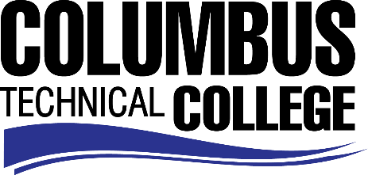

Position Announcement

Instructional Aide – Automotive Collision Repair Program
Columbus Technical College is seeking an individual to serve as a part-time Instructional Aide in our Automotive Collision Repair department. This individual will be responsible for assisting students and instructors in the Automotive Collision Repair labs. This position is part-time/non-exempt.
Responsibilities:
- Monitors students in skilled or basic areas Automotive Collision Repair
- Assist instructor and students in various areas of lab exercises
- Monitors and maintains supplies and equipment
- Maintains and cleans classroom and laboratory
- Demonstrates effective oral and written communication skills
- Ensures safety and security requirements are met in the lab areas
Minimum Qualifications
- A High School Diploma or GED
- Graduate of Automotive Collision Repair program
- A minimum of one year in field work experience in Automotive Collision
Salary/Benefits
Pay is $14 per hour with no benefits.
Application Deadline
Applications accepted through March 28, 2019. Applicants must submit a Columbus Technical College employment application online at: https://www.easyhrweb.com/JC_Columbus/JobListings/JobListings.aspx and upload a cover letter, resume and copy of transcript(s) at time of application (Incomplete submissions will not be considered). **Please note: All references will be checked prior to employment offer. Post offer requirements will include a criminal background check and motor vehicle records check. **

Employment Policy
The Technical College System of Georgia and its constituent Technical Colleges do not discriminate on the basis of race, color, creed, national or ethnic origin, gender, religion, disability, age, political affiliation or belief, genetic information, disabled veteran, veteran of the Vietnam Era, spouse of military member or citizenship status (except in those special circumstances permitted or mandated by law). This nondiscrimination policy encompasses the operation of all technical college-administered programs, programs financed by the federal government including any Workforce Investment Act of 1998 (WIA) Title I financed programs, educational programs and activities, including admissions, scholarships and loans, student life, and athletics. It also encompasses the recruitment and employment of personnel and contracting for goods and services.

The Technical College System of Georgia and its colleges shall promote the realization of equal opportunity through a positive continuing program of specific practices. The following persons have been designated to handle inquiries regarding the nondiscrimination policies for Columbus Technical College: Karen Thomas, Title IX Coordinator, at 706.649.1813 and Olive Vidal-Kendall, Section 504 Coordinator, at 706.649.1442.

