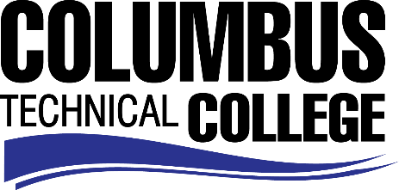

Position Announcement

Adult Education Instructor English as a Second Language (ESL) – Part-time
Columbus Technical College is seeking an individual to serve as a Part-time ESL Instructor for our Adult Education Program for an evening classes located on campus and at our Fort Benning location. This is an hourly paid position with employment being contingent upon program enrollment. This individual will be responsible for preparation and delivery of lesson plans and routine daily maintenance for classroom instruction. This position also requires evaluation of student progress in attaining goals and objectives; attend staff development training, workshops, seminars, and conferences, and ensure all safety and security requirements are met in trainings
Responsibilities:
- Instruct students through English only instruction, in English as a Second Language core curriculum
- Follow state standards to develop lesson plans, using clearly stated goals and objectives
- Evaluate students’ progress in attaining goals and objectives
- Provide learning guidance and feedback to students
- Develop teaching methods and maintain management procedures and documentation
- Promote the adult education / ESL program to public and private organizations through the Service Delivery Area
- Ensure safety and security requirements are met in the training areas
- Monitor class attendance and assist with recruitment and retention efforts
- Employ strong time management and organizational skills
- Use effective written and oral communication
- Possess general computer knowledge (Microsoft Word, Excel)
- Administer pre and post-test to ascertain English proficiency as required
- Other job related duties as assigned
Minimum Qualifications
- Completion of a bachelor's degree from a college or university, preferably in education or a related field.
Preferred Qualifications
- One year specialized experience teaching English as a Second Language in a classroom setting
- GALIS Knowledge
Salary/Benefits
Salary is commensurate with education and experience.
Application Deadline
For consideration, applications should be received by February 21, 2018. Applicants must submit a Columbus Technical College employment application online at www.columbustech.edu CTC Employment, and upload a cover letter and resume at time of application (Incomplete submissions will not be considered). Background check is required.
Employment Policy
The Technical College System of Georgia and its constituent Technical Colleges do not discriminate on the basis of race, color, creed, national or ethnic origin, sex, religion, disability, age, political affiliation or belief, genetic information, disabled veteran, veteran of the Vietnam Era, spouse of military member or citizenship status (except in those special circumstances permitted or mandated by law). This nondiscrimination policy encompasses the operation of all technical college-administered programs, programs financed by the federal government including any Workforce Innovation and Opportunity Act (WIOA) Title I financed programs, educational programs and activities, including admissions, scholarships and loans , student life, and athletics. It also encompasses the recruitment and employment of personnel and contracting for goods and services.
The Technical College System and Technical Colleges shall promote the realization of equal opportunity through a positive continuing program of specific practices designed to ensure the full realization of equal opportunity. The following person has been designated to handle inquiries regarding the nondiscrimination policies for Columbus Technical College: Patricia Hood, Executive Director of Human Resources and Title IX and Section 504 Coordinator, 928 Manchester Expressway, Columbus, GA 31904 or 706-649-1883.

