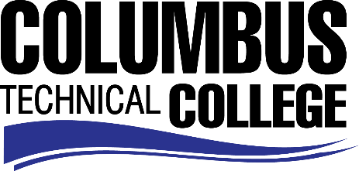

Position Announcement

Anatomy & Physiology Adjunct Instructor
Columbus Technical College is seeking an individual to serve as an adjunct instructor for Anatomy and Physiology. Under general supervision, this individual will prepare lesson plans for classroom instruction, and evaluate students’ progress in attaining goals, objectives, and student learning outcomes. This is a part-time position that requires day or evening instruction in a traditional classroom setting. This position is part-time/exempt.
Responsibilities:
- Ensures adherence to technical college and safety requirements in classrooms and labs by following established procedures.
- Correctly assesses the educational needs and class progress of students.
- Selects and obtains appropriate educational materials for courses.
- Prepares reports on the current status of students in the program indicating whether performance is aligned with performance indicators, program goals and progress schedule.
- Ensures consistency in syllabi, lesson plans, tests, and other appropriate materials.
- Prepares appropriate curricula, including non-traditional content and methods to achieve objectives and goals of students.
- Student advisement
- Participation in program committees
- Contribute to the writing of accreditation and assessment reports
- Proficient with current applications in computer technology; Word, Excel, etc.
Minimum Qualifications
- A Master’s Degree in Anatomy & Physiology or a related field from a regionally accredited college or university.
-OR-
- A Master’s Degree with a minimum of 18 graduate semester credit hours or 27 graduate quarter hours in Anatomy & Physiology from a regionally accredited college or university.
Salary/Benefits
Salary is commensurate with education and experience.
Application Deadline
Application Deadline
Applications accepted through August 14, 2019. Applicants must submit a Columbus Technical College employment application online at: https://www.easyhrweb.com/JC_Columbus/JobListings/JobListings.aspx and upload a cover letter, resume and copy of transcript(s) at time of application (Incomplete submissions will not be considered). **Please note: All references will be checked prior to employment offer. Post offer requirements will include a criminal background check and motor vehicle records check. **
Employment Policy
The Technical College System of Georgia and its constituent Technical Colleges do not discriminate on the basis of race, color, creed, national or ethnic origin, gender, religion, disability, age, political affiliation or belief, genetic information, disabled veteran, veteran of the Vietnam Era, spouse of military member or citizenship status (except in those special circumstances permitted or mandated by law). This nondiscrimination policy encompasses the operation of all technical college-administered programs, programs financed by the federal government including any Workforce Investment Act of 1998 (WIA) Title I financed programs, educational programs and activities, including admissions, scholarships and loans, student life, and athletics. It also encompasses the recruitment and employment of personnel and contracting for goods and services.

The Technical College System of Georgia and its colleges shall promote the realization of equal opportunity through a positive continuing program of specific practices. The following persons have been designated to handle inquiries regarding the nondiscrimination policies for Columbus Technical College: Henry Gross, Title IX Coordinator, at 706.649.1883 and Olive Vidal-Kendall, Section 504 Coordinator, at 706.649.1442.

