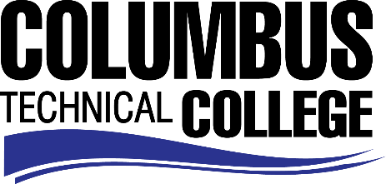

Position Announcement

Adjunct Instructor -Chemistry
Columbus Technical College is seeking an individual to serve as an adjunct instructor for Chemistry. Under general supervision, this individual will prepare lesson plans for classroom instruction, and evaluate students’ progress in attaining goals, objectives, and student learning outcomes. This position is part-time/non-exempt.
Responsibilities:
- Ensures adherence to technical college and safety requirements in classrooms and labs by following established procedures;
- Correctly assesses the educational needs and class progress of students;
- Selects and obtains appropriate educational materials for courses;
- Prepares reports on the current status of students in the program indicating whether performance is aligned with performance indicators, program goals and progress schedule;
- Ensures consistency in syllabi, lesson plans, tests, and other appropriate material;
- Prepares appropriate curricula, including non-traditional content and methods to achieve objectives and goals of students;
- Student advisement;
- Contribute to the writing of accreditation and assessment reports
- Participation in program committees;
- Proficient with current applications in computer technology; Word, Excel, etc.
Minimum Qualifications
- A Master’s Degree from a regionally accredited college or university in Chemistry
OR
- A Master’s Degree from a regionally accredited college or university with a minimum of 18 graduate semester hours or 27 graduate quarter hours in Chemistry
Salary/Benefits
Salary is commensurate with education and experience.
Application Deadline
This position is available until filled. Applicants must submit a Columbus Technical College employment application online at www.columbustech.edu CTC Employment, and upload a cover letter and resume at time of application (Incomplete submissions will not be considered). Background check is required.
Employment Policy
The Technical College System of Georgia and its constituent Technical Colleges do not discriminate on the basis of race, color, creed, national or ethnic origin, gender, religion, disability, age, political affiliation or belief, genetic information, disabled veteran, veteran of the Vietnam Era, spouse of military member or citizenship status (except in those special circumstances permitted or mandated by law). This nondiscrimination policy encompasses the operation of all technical college-administered programs, programs financed by the federal government including any Workforce Investment Act of 1998 (WIA) Title I financed programs, educational programs and activities, including admissions, scholarships and loans, student life, and athletics. It also encompasses the recruitment and employment of personnel and contracting for goods and services.

The Technical College System of Georgia and its colleges shall promote the realization of equal opportunity through a positive continuing program of specific practices. The following person has been designated to handle inquiries regarding the nondiscrimination policies for Columbus Technical College: Patricia Hood, Executive Director of Human Resources and Title IX and Section 504 Coordinator, 928 Manchester Expressway, Columbus, GA 31904 or 706-649-1883.

