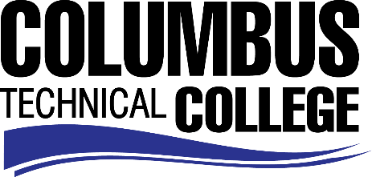

Position Announcement

Instructional Aide – Computer Support Lab (Part-time)
Columbus Technical College is seeking an individual to serve as a part-time Instructional Aide in our Computer Support Lab. This individual will assist instructors with providing education and/or training to CTC students. This position is part-time/non-exempt.
Responsibilities:
- Assists instructor with classroom presentations;
- Assists instructor in maintaining an effective learning environment;
- Completes documentation of student progress;
- Performs various types of clerical tasks to assist instructor;
- Prepares materials, exhibits, equipment and demonstrations;
- Requests and maintains assigned classroom supplies, materials and equipment;
- Tutors and assists individual students in the learning environment.

Minimum Qualifications
- High School Diploma or GED

Preferred Qualifications
- In addition to minimum qualifications, prefer applicants with a minimum grade of B or higher in Comp 1000 and/or demonstrated competency in tutoring individuals in computer skills.

Competencies
- Skill in oral and written communication
- Knowledge of State Board Policies
- Ability to assist students individually or in groups
- Ability to maintain accurate records
- Ability to prepare lesson materials
- Ability to operate workroom machinery such as fax machines, copiers, scanners, shredders, etc.

Salary/Benefits
Pay rate is $9.50 per hour
Application Deadline
Applications accepted through March 28, 2019. Applicants must submit a Columbus Technical College employment application online at: https://www.easyhrweb.com/JC_Columbus/JobListings/JobListings.aspx and upload a cover letter, resume and copy of transcript(s) at time of application (Incomplete submissions will not be considered). **Please note: All references will be checked prior to employment offer. Post offer requirements will include a criminal background check and motor vehicle records check. **

Employment Policy
The Technical College System of Georgia and its constituent Technical Colleges do not discriminate on the basis of race, color, creed, national or ethnic origin, gender, religion, disability, age, political affiliation or belief, genetic information, disabled veteran, veteran of the Vietnam Era, spouse of military member or citizenship status (except in those special circumstances permitted or mandated by law). This nondiscrimination policy encompasses the operation of all technical college-administered programs, programs financed by the federal government including any Workforce Investment Act of 1998 (WIA) Title I financed programs, educational programs and activities, including admissions, scholarships and loans, student life, and athletics. It also encompasses the recruitment and employment of personnel and contracting for goods and services.

The Technical College System of Georgia and its colleges shall promote the realization of equal opportunity through a positive continuing program of specific practices. The following persons have been designated to handle inquiries regarding the nondiscrimination policies for Columbus Technical College: Karen Thomas, Title IX Coordinator, at 706.649.1813 and Olive Vidal-Kendall, Section 504 Coordinator, at 706.649.1442.

