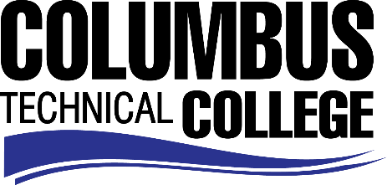

Position Announcement

Instructional Aide (Part-time) - Cosmetology Program
Columbus Technical College is seeking an individual to serve as a part-time Instructional Aide in our Cosmetology Department. This individual will be responsible for assisting students and instructors in the areas of cosmetology to include hair, skin and nails. This position is part-time/non-exempt.
Responsibilities:
- Monitors students in skilled or basic areas of multicultural training
- Assist instructors and students in various areas
- Monitors and maintains supplies and equipment
- Demonstrates knowledge of current procedures in the Cosmetology field
- Maintains clean classroom and laboratories
- Demonstrates effective oral and written communication skills
- Ensures safety and security requirements are met in the training areas
Minimum Qualifications
- A High School Diploma or GED
- A minimum of 6 months recent in field work experience providing services in a Cosmetology field to include skills in multi-cultural hair and knowledge of facial machines
- Current Georgia State Board of Cosmetology Master License
- Basic Computer Skills
- Excellent work ethics and customer service
Salary/Benefits
Salary is commensurate with education and experience.
Application Deadline
Position is available until filled. Applicants must submit a Columbus Technical College employment application online at www.columbustech.edu CTC Employment, and upload a cover letter and resume, and a copy of official transcripts at time of application (Incomplete submissions will not be considered). Background check is required.
Employment Policy
The Technical College System of Georgia and its constituent Technical Colleges do not discriminate on the basis of race, color, creed, national or ethnic origin, gender, religion, disability, age, political affiliation or belief, genetic information, disabled veteran, veteran of the Vietnam Era, spouse of military member or citizenship status (except in those special circumstances permitted or mandated by law). This nondiscrimination policy encompasses the operation of all technical college-administered programs, programs financed by the federal government including any Workforce Investment Act of 1998 (WIA) Title I financed programs, educational programs and activities, including admissions, scholarships and loans, student life, and athletics. It also encompasses the recruitment and employment of personnel and contracting for goods and services.

The Technical College System of Georgia and its colleges shall promote the realization of equal opportunity through a positive continuing program of specific practices. The following person has been designated to handle inquiries regarding the nondiscrimination policies for Columbus Technical College: Patricia Hood, Executive Director of Human Resources and Title IX and Section 504 Coordinator, 928 Manchester Expressway, Columbus, GA 31904 or 706-649-1883.

