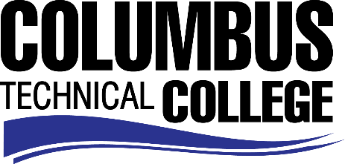

Position Announcement

Criminal Justice Adjunct Instructor
Columbus Technical College is seeking an individual to serve as an adjunct instructor for the Criminal Justice Program. Under general supervision, this individual will prepare lesson plans for classroom instruction, and evaluate students’ progress in attaining goals, objectives, and student learning outcomes. This position is part-time/exempt.
Responsibilities:
- Delivers effective individualized program and instruction to class members
- Ensures adherence to technical college and safety requirements in classrooms and labs by following established procedures
- Selects and obtains appropriate educational materials for courses
- Ensures consistency in syllabi, lesson plans, test, and other appropriate course work
- Monitors use of and maintains supplies, equipment and/or facilities for assigned program.
- Assists with recruiting and marketing activities
- Assists with registration and orientation functions
- Participates in standing or ad hoc committee meetings relating to curriculum development, extra curricula activities, and other technical college sponsored activities or programs as required
- Assists with the design and execution of special events, projects and activities as requested
- Displays a high level of effort and commitment to performing work; operates effectively within the organizational structure; demonstrates trustworthiness and responsible behavior.
Minimum Qualifications
- A Master’s Degree from an accredited institution in the teaching discipline (i.e. Criminal Justice, Justice Administration) *and* One or more years of experience in the criminal justice work force
-OR-
- A Master’s Degree from an accredited institution with a concentration in the teaching discipline (minimum 18 graduate semester hours or 27 graduate quarter hours) *and* One or more years of experience in the criminal justice work force
Salary/Benefits
Salary is commensurate with education and experience.

Application Deadline

Applications accepted through August 21, 2019. Applicants must submit a Columbus Technical College employment application online at: https://www.easyhrweb.com/JC_Columbus/JobListings/JobListings.aspx and upload a cover letter, resume and copy of transcript(s) at time of application (Incomplete submissions will not be considered). **Please note: All references will be checked prior to employment offer. Post offer requirements will include a criminal background check and motor vehicle records check. **

Employment Policy
The Technical College System of Georgia and its constituent Technical Colleges do not discriminate on the basis of race, color, creed, national or ethnic origin, gender, religion, disability, age, political affiliation or belief, genetic information, disabled veteran, veteran of the Vietnam Era, spouse of military member or citizenship status (except in those special circumstances permitted or mandated by law). This nondiscrimination policy encompasses the operation of all technical college-administered programs, programs financed by the federal government including any Workforce Investment Act of 1998 (WIA) Title I financed programs, educational programs and activities, including admissions, scholarships and loans, student life, and athletics. It also encompasses the recruitment and employment of personnel and contracting for goods and services.
The Technical College System of Georgia and its colleges shall promote the realization of equal opportunity through a positive continuing program of specific practices. The following persons have been designated to handle inquiries regarding the nondiscrimination policies for Columbus Technical College: Henry Gross, Title IX Coordinator, at 706.649.1883 and Olive Vidal-Kendall, Section 504 Coordinator, at 706.649.1442.

