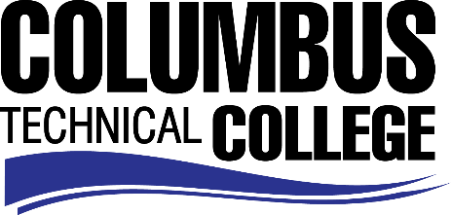

Position Announcement

Instructional Aide (Part-time) – Culinary Arts Program
Columbus Technical College is seeking an individual to serve as a part-time Instructional Aide in our Culinary Arts Department. This individual will be responsible for assisting students and instructors in the areas of cosmetology to include hair, skin and nails. This position is part-time/non-exempt.
Responsibilities:
- Monitors students in skilled or basic areas Culinary Arts
- Assist instructor and students in various areas of lab exercises
- Monitors and maintains supplies and equipment
- Maintains and cleans classroom, kitchen and other areas as needed
- Demonstrates effective oral and written communication skills
- Ensures safety and security requirements are met in the kitchen areas
Minimum Qualifications
- A High School Diploma or GED
- Current ServSafe Certification
- Graduate of Culinary Arts Certificate or Diploma program
- A minimum of 12 months recent in field work experience in Culinary Arts
- Excellent work ethics and customer service
- Basic Computer Skills
Salary/Benefits
Salary is commensurate with education and experience.
Application Deadline
Position is available until filled. Applicants must submit a Columbus Technical College employment application online at www.columbustech.edu CTC Employment, and upload a cover letter and resume, and a copy of official transcripts at time of application (Incomplete submissions will not be considered). Background check is required.
Employment Policy
The Technical College System of Georgia and its constituent Technical Colleges do not discriminate on the basis of race, color, creed, national or ethnic origin, gender, religion, disability, age, political affiliation or belief, genetic information, disabled veteran, veteran of the Vietnam Era, spouse of military member or citizenship status (except in those special circumstances permitted or mandated by law). This nondiscrimination policy encompasses the operation of all technical college-administered programs, programs financed by the federal government including any Workforce Investment Act of 1998 (WIA) Title I financed programs, educational programs and activities, including admissions, scholarships and loans, student life, and athletics. It also encompasses the recruitment and employment of personnel and contracting for goods and services.

The Technical College System of Georgia and its colleges shall promote the realization of equal opportunity through a positive continuing program of specific practices. The following person has been designated to handle inquiries regarding the nondiscrimination policies for Columbus Technical College: Patricia Hood, Executive Director of Human Resources and Title IX and Section 504 Coordinator, 928 Manchester Expressway, Columbus, GA 31904 or 706-649-1883.

