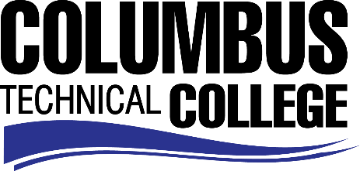

Position Announcement

Custodian – Part-time
Columbus Technical College is seeking an individual to serve as a Part-time Custodian in our Operations Department. This individual will be responsible for maintenance, proper safety and cleaning procedures. This position requires physical demands stooping, bending, pushing, pulling, lifting up to 75 lbs. or more when necessary and use of various chemicals on a daily basis. This position is part-time/non-exempt.
Responsibilities:
- Maintains proper care of a facilities;
- Provides care and routine maintenance of grounds;
- Clears storm drains and traps of debris;
- Performs a variety of duties related to the job, such as painting, replacing light bulbs, hanging curtains, moving furniture, setting up chairs, tables, lights and podiums for special events and college functions;
- Distributes and maintains materials, tools and equipment;
- Clean bathrooms, classrooms, hallways, other areas of facility
- Use various chemicals to maintain facilities
- Proper use and storage of various chemicals
Minimum Qualifications
- No minimum requirements
Preferred Qualifications
- A High School Diploma or GED
- Minimum of 6 months’ work experience in custodial services
- Knowledge of all aspects of cleaning, e.g., carpet, resilient tile, hardwood floors
- Ability to communicate effectively
- Willingness to learn and/or contribute to the college operations program
Salary/Benefits
Salary is commensurate with education and experience.
Application Deadline
For consideration, applications should be received by October 3, 2017. Applicants must submit a Columbus Technical College employment application online at www.columbustech.edu CTC Employment, and upload a cover letter and resume at time of application (Incomplete submissions will not be considered). Background check is required.
Employment Policy
The Technical College System of Georgia and its constituent Technical Colleges do not discriminate on the basis of race, color, creed, national or ethnic origin, gender, religion, disability, age, political affiliation or belief, genetic information, disabled veteran, veteran of the Vietnam Era, spouse of military member or citizenship status (except in those special circumstances permitted or mandated by law). This nondiscrimination policy encompasses the operation of all technical college-administered programs, programs financed by the federal government including any Workforce Investment Act of 1998 (WIA) Title I financed programs, educational programs and activities, including admissions, scholarships and loans, student life, and athletics. It also encompasses the recruitment and employment of personnel and contracting for goods and services.

The Technical College System of Georgia and its colleges shall promote the realization of equal opportunity through a positive continuing program of specific practices. The following person has been designated to handle inquiries regarding the nondiscrimination policies for Columbus Technical College: Patricia Hood, Executive Director of Human Resources and Title IX and Section 504 Coordinator, 928 Manchester Expressway, Columbus, GA 31904 or 706-649-1883.

