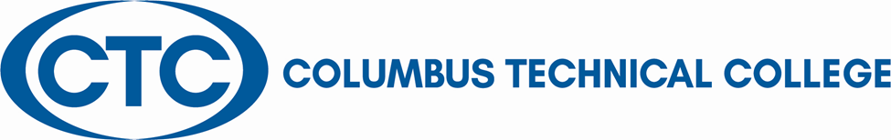

Position Announcement

Dental Hygiene Program Director\Instructor- Full Time
Columbus Technical College is seeking an individual to serve as a full-time instructor for the Dental Hygiene Program and as the Program Administrator. The faculty member will provide theory and practical instruction to a level sufficient for students to develop the skills necessary to become employed in the profession of Dental Hygiene. This individual will be responsible for general supervision, preparation of lesson plans and lab instruction within the dental clinic/classroom. This position also requires attendance to staff development training, workshops, seminars, and conferences and ensure all safety and security requirements are met in trainings. This position is Full-time/exempt.
Please note the following information regarding this position:
- May be required to teach high school students
- May require teaching on or off campus throughout our service delivery area (Muscogee County, Stewart County, Quitman County, Chattahoochee County, Harris County, and Talbot County)
- May require travel

Responsibilities:
- Teach both didactic and clinical courses as assigned and perform other assignments required by accreditation.
- Responsible for faculty recruitment, assignments and supervision
- Initiation of program or department in-service and faculty development
- Coordination, evaluation and participation in determining admission criteria and procedures as well as student promotion and retention criteria
- Responsibility for program policy and procedures, budgeting and planning, student and program outcomes, curriculum, regulatory training, staff and faculty development, personnel administration, clinic management and oversight, quality assurance and acquisition of instructional technology, clinic equipment and operational resources
- Responsible for the coordination, planning, presentation, and evaluation of classroom instruction and related activities.
- Provides leadership, vision, input and participation in School activities sufficient to fulfill the College's Vision and Mission, and to sustain Dental Hygiene Program excellence.
- Follow state standards in developing program and course outlines, goals and objectives
- Evaluate students’ progress in attaining goals and objectives
- Request and maintain supplies, tools, and equipment, and prepare budget requests
- Develop teaching methods and maintain management procedures and documentation
- Meet with students, staff members and other educators to discuss students’ instructional programs and other issues impacting the progress of the students
- Ensure safety and security requirements are met in the training areas
- Student advisement and registration
- Assist with recruitment, retention, and job placement efforts
- Maintain program certification requirements, as appropriate
- Strong time management and organization skills
- Effective written and oral communication
- Keen observation, supervision and evaluation skills
- Serves on committees as directed and coordinated by the program director or Dean of Health Sciences
- General Computer knowledge (Microsoft Word, Excel, Power Point)
- Other job related duties as assigned
Minimum Qualifications
- A Registered Dental Hygienist with a current Georgia license who is a graduate of a program accredited by the Commission on Dental Accreditation
-AND-
- A Master’s Degree or higher or is currently enrolled in a master’s degree program
- Background in Education
- Experience teaching college level courses
- A current CPR card
- Minimum of three (3) year work experience as a dental hygiene didactic and clinical instructor
- Proficient with current applications in computer technology

Preferred Qualifications
- Previous program director experience
- Previous leadership experience of faculty and staff in community college setting
- Previous experience with CODA accreditation process
Salary/Benefits
Salary is commensurate with education and experience. Benefits include state holidays, annual leave, and sick leave, State of Georgia Retirement, Health and Flexible Benefits Program.
Application Deadline
Applications accepted until filled. Applicants must submit a Columbus Technical College employment application online at: https://www.easyhrweb.com/JC_Columbus/JobListings/JobListings.aspx and upload a cover letter, resume and copy of transcript(s) at time of application (Incomplete submissions will not be considered). **Please note: All references will be checked prior to employment offer. Post offer requirements will include a criminal background check and motor vehicle records check. **
Employment Policy
The Technical College System of Georgia and its constituent Technical Colleges do not discriminate on the basis of race, color, creed, national or ethnic origin, gender, religion, disability, age, political affiliation or belief, genetic information, disabled veteran, veteran of the Vietnam Era, spouse of military member or citizenship status (except in those special circumstances permitted or mandated by law). This nondiscrimination policy encompasses the operation of all technical college-administered programs, programs financed by the federal government including any Workforce Investment Act of 1998 (WIA) Title I financed programs, educational programs and activities, including admissions, scholarships and loans, student life, and athletics. It also encompasses the recruitment and employment of personnel and contracting for goods and services.
The Technical College System of Georgia and its colleges shall promote the realization of equal opportunity through a positive continuing program of specific practices. The following persons have been designated to handle inquiries regarding the nondiscrimination policies for Columbus Technical College: Henry Gross, Title IX Coordinator, at 706.649.1883 and Olive Vidal-Kendall, Section 504 Coordinator, at 706.649.1442.

