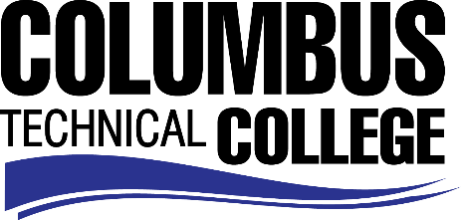

Position Announcement

Drafting Technology Adjunct Instructor
Columbus Technical College is seeking an individual to serve as a part-time Adjunct Instructor in our Drafting Technology Department. This individual will assist instructors with providing education and/or training to CTC students. This is a temporary part-time position for summer semester.
Responsibilities:
- Instruct students in drafting technology skill areas
- Follow state standards in developing program and course outlines, goals and objectives
- Evaluate students’ progress in attaining goals and objectives
- Maintain supplies, tools, and equipment
- Maintain management procedures and documentation
- Meet with students, staff members and other educators to discuss students’ progress
- Ensure safety and security requirements are met in the training areas
- Respond in a timely manner to administrative requests
- Assist with recruitment, retention, and job placement efforts
- Strong time management and organization skills
- Effective written and oral communication
- Keen observation, supervision and evaluation skills
- General Computer knowledge (Microsoft Word, Excel)
- Experience with Autodesk (CAD Software)
- Other job related duties as assigned
Minimum Qualifications
- Academic requirement:
  - An Associate Degree from an accredited college or university
-OR-
  - Diploma in Drafting Technology from an accredited college or technical institution
- Minimum of 3 years work experience in the drafting field
- Training or teaching experience
Salary
Salary is commensurate with education and experience.
Application Deadline
Position is available until June 29, 2018. Applicants must submit a Columbus Technical College employment application online at www.columbustech.edu CTC Employment, and upload a cover letter, resume, and copy of college transcripts at time of application (Incomplete submissions will not be considered). Background check is required.
Employment Policy
The Technical College System of Georgia and its constituent Technical Colleges do not discriminate on the basis of race, color, creed, national or ethnic origin, gender, religion, disability, age, political affiliation or belief, genetic information, disabled veteran, veteran of the Vietnam Era, spouse of military member or citizenship status (except in those special circumstances permitted or mandated by law). This nondiscrimination policy encompasses the operation of all technical college-administered programs, programs financed by the federal government including any Workforce Investment Act of 1998 (WIA) Title I financed programs, educational programs and activities, including admissions, scholarships and loans, student life, and athletics. It also encompasses the recruitment and employment of personnel and contracting for goods and services.

The Technical College System of Georgia and its colleges shall promote the realization of equal opportunity through a positive continuing program of specific practices. The following person has been designated to handle inquiries regarding the nondiscrimination policies for Columbus Technical College: Patricia Hood, Executive Director of Human Resources and Title IX and Section 504 Coordinator, 928 Manchester Expressway, Columbus, GA 31904 or 706-649-1883.

