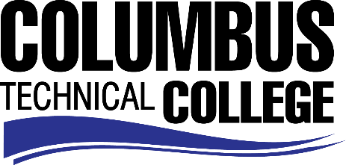

Position Announcement

Early Childhood Care and Education Instructor –Full Time
Columbus Technical College is seeking an individual to serve as a full-time instructor for Early Childhood Care and Education. Under general supervision, this individual will prepare lesson plans for classroom instruction, and evaluate students’ progress in attaining goals, objectives, and student learning outcomes. This position is full-time/exempt.
Responsibilities:
- Delivers effective individualized program and instruction to class members
- Ensures adherence to technical college and safety requirements in classrooms and labs by following established procedures
- Ensures consistency in syllabi, lesson plans, test, and other appropriate course work
- Displays a high level of effort and commitment to performing work; operates effectively within the organizational structure; demonstrates trustworthiness and responsible behavior.
- Constructs quality assessment plans
- Serves on college committees
- Recruit and retain students
Minimum Qualifications
- A Master’s Degree in Early Childhood Care & Education from a regionally accredited college or university;
-OR-
- A Master’s Degree in a related field with 18 semester hours or 27 quarter hours in Early Childhood Care & Education
Preferred Qualifications
In addition to the minimum qualifications, one or more years’ teaching experience.
Salary/Benefits
Salary is commensurate with education and experience. Benefits include state holidays, annual leave, and sick leave, State of Georgia Retirement, Health and Flexible Benefits Program.
Application Deadline
Applications accepted through August 27, 2019. Applicants must submit a Columbus Technical College employment application online at: https://www.easyhrweb.com/JC_Columbus/JobListings/JobListings.aspx and upload a cover letter, resume and copy of transcript(s) at time of application (Incomplete submissions will not be considered). **Please note: All references will be checked prior to employment offer. Post offer requirements will include a criminal background check and motor vehicle records check. **
Employment Policy
The Technical College System of Georgia and its constituent Technical Colleges do not discriminate on the basis of race, color, creed, national or ethnic origin, gender, religion, disability, age, political affiliation or belief, genetic information, disabled veteran, veteran of the Vietnam Era, spouse of military member or citizenship status (except in those special circumstances permitted or mandated by law). This nondiscrimination policy encompasses the operation of all technical college-administered programs, programs financed by the federal government including any Workforce Investment Act of 1998 (WIA) Title I financed programs, educational programs and activities, including admissions, scholarships and loans, student life, and athletics. It also encompasses the recruitment and employment of personnel and contracting for goods and services.

The Technical College System of Georgia and its colleges shall promote the realization of equal opportunity through a positive continuing program of specific practices. The following persons have been designated to handle inquiries regarding the nondiscrimination policies for Columbus Technical College: Henry Gross, Title IX Coordinator, at 706.649.1883 and Olive Vidal-Kendall, Section 504 Coordinator, at 706.649.1442.

