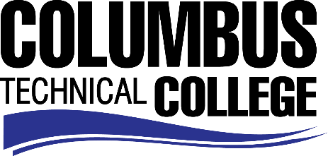

Position Announcement

Part Time Instructor (Adjunct) – Esthetics Program
Columbus Technical College is seeking an individual to serve as a part-time Technical Instructor in our Esthetics Department. This individual will be responsible for teaching in all areas of Esthetics along with general supervision, preparation of lesson plans for classroom and lab hands on lab instruction. This position also requires evaluation of student progress in attaining goals and objectives; attend staff development training, workshops, seminars, and conferences, and ensure all safety and security requirements are met in trainings. This position is part-time/non-exempt.
Responsibilities:
      - Instruct students in all areas of Esthetics
      - Follow state standards in developing program and course outlines, goals and objectives
      - Evaluate students’ progress in attaining goals and objectives
      - Request and maintain supplies, tools and equipment
      - Develop teaching methods and maintain management procedures and documentation
      - Meet with students, staff members and other educators to discuss students’ instructional programs and other issues impacting the progress of the students
      - Ensure safety and security requirements are met in the training areas
      - Assist with recruitment, retention, and job placement efforts
      - Maintain program certification requirements, as appropriate
      - Strong time management and organization skills
      - Effective written and oral communication
      - Keen observation, supervision and evaluation skills
      - General Computer knowledge (Microsoft Word, Excel)
      - Other job related duties as assigned
Minimum Qualifications
- High School Diploma or GED
- Completion of a Cosmetology or Esthetics Programs from an accredited college or institution
-And-
- A minimum of 3 years recent in field work experience as an Esthetician or Esthetics Instructor
- Current Georgia State Board of Cosmetology and Barbering Master Cosmetology or Esthetics License
- Basic Computer Skills

Preferred Qualifications
- Current Georgia State Board of Cosmetology and Barbering Esthetics Instructor License
Salary/Benefits
Salary is commensurate with education and experience.
Application Deadline
This position is available until filled. Applicants must submit a Columbus Technical College employment application online at www.columbustech.edu CTC Employment, and upload a cover letter and resume at time of application (Incomplete submissions will not be considered). Background check is required.
Employment Policy
The Technical College System of Georgia and its constituent Technical Colleges do not discriminate on the basis of race, color, creed, national or ethnic origin, sex, religion, disability, age, political affiliation or belief, genetic information, disabled veteran, veteran of the Vietnam Era, spouse of military member or citizenship status (except in those special circumstances permitted or mandated by law). This nondiscrimination policy encompasses the operation of all technical college-administered programs, programs financed by the federal government including any Workforce Innovation and Opportunity Act (WIOA) Title I financed programs, educational programs and activities, including admissions, scholarships and loans , student life, and athletics. It also encompasses the recruitment and employment of personnel and contracting for goods and services.
The Technical College System and Technical Colleges shall promote the realization of equal opportunity through a positive continuing program of specific practices designed to ensure the full realization of equal opportunity. The following person has been designated to handle inquiries regarding the nondiscrimination policies for Columbus Technical College: Patricia Hood, Executive Director of Human Resources and Title IX and Section 504 Coordinator, 928 Manchester Expressway, Columbus, GA 31904 or 706-649-1883.

