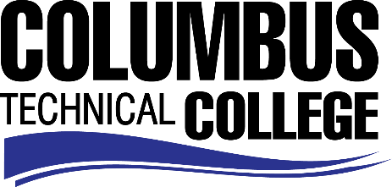

Position Announcement

Position: Federal Work Study Student – Office Assistant
Location: Academic Advisement Center
Nature of Duties: The Office Assistant is responsible greeting internal and external customers in person or on the telephone.
Responsibilities:
- Operates a multi-line telephone console in order to relay incoming and outgoing calls;
- Greets persons entering establishment;
- Provides information or directs calls/visits to appropriate office or individual;
- Operates office machines and computers for the purpose of creating identification cards and using Microsoft Office to create documents;
- Provides clerical support such as typing, filing, data entry;
- Assist Manager and Academic Advisors as needed with work duties;
- Assists with coordination of special events on campus, i.e., graduation activities and registration activities;
- Perform other duties as assigned.
Minimum Qualifications:
- Be enrolled as a student at Columbus Technical College
- Completed a FAFSA and be identified as being eligible for federal aid
- Complete a Federal Work-Study Employment Application

Salary/Benefits: $7.50 per hour; no benefits
Method of Application: Interested candidates must complete electronic application process at www.columbustech.edu, CTC Careers, Federal Work Study.
Employment Policy: The Technical College System of Georgia and its constituent Technical Colleges do not discriminate on the basis of race, color, creed, national or ethnic origin, gender, religion, disability, age, political affiliation or belief, genetic information, disabled veteran, veteran of the Vietnam Era, spouse of military member or citizenship status (except in those special circumstances permitted or mandated by law). This nondiscrimination policy encompasses the operation of all technical college-administered programs, programs financed by the federal government including any Workforce Investment Act of 1998 (WIA) Title I financed programs, educational programs and activities, including admissions, scholarships and loans, student life, and athletics. It also encompasses the recruitment and employment of personnel and contracting for goods and services.

The Technical College System of Georgia and its colleges shall promote the realization of equal opportunity through a positive continuing program of specific practices. The following persons have been designated to handle inquiries regarding the nondiscrimination policies for Columbus Technical College: Henry Gross, Title IX Coordinator, at 706.649.1883 and Olive Vidal-Kendall, Section 504 Coordinator, at 706.649.1442.

