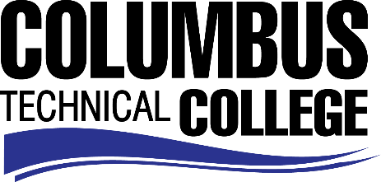

Position Announcement

Position: Federal Work Study Student – Career Center Specialist (Off-Campus)
Location: Goodwill Industries of the Southern Rivers/Career Center.
Nature of Duties: The Work-study student is responsible for supporting day-to-day activities within the Goodwill Industries of the Southern Rivers (GoodwillSR) career center with the focus of assisting and providing resources to individuals who are unemployed or underemployed.

Duties include the following:
- Greet and engage visitors and callers
- Perform general reception services, including answering telephones and taking messages
- Obtain client information and track it appropriately in the organization’s client management system
- Maintain familiarity with the resources that the career center provides as well as community resources
- Assist clients with using the career center’s resources; answer questions and give appropriate guidance
- Assist with data entry
- Perform filing, photocopying, mass mailings and other related activities

Minimum Qualifications:
- Be enrolled as a student at Columbus Technical College
- Completed a FAFSA and be identified as being eligible for federal aid
- Complete a Federal Work-Study Employment Application

Salary/Benefits: $8.50 per hour; no benefits
Method of Application: Interested candidates must complete electronic application process at www.columbustech.edu, CTC Careers, Federal Work Study.
Employment Policy: The Technical College System of Georgia and its constituent Technical Colleges do not discriminate on the basis of race, color, creed, national or ethnic origin, gender, religion, disability, age, political affiliation or belief, genetic information, disabled veteran, veteran of the Vietnam Era, spouse of military member or citizenship status (except in those special circumstances permitted or mandated by law). This nondiscrimination policy encompasses the operation of all technical college-administered programs, programs financed by the federal government including any Workforce Investment Act of 1998 (WIA) Title I financed programs, educational programs and activities, including admissions, scholarships and loans, student life, and athletics. It also encompasses the recruitment and employment of personnel and contracting for goods and services.

The Technical College System of Georgia and its colleges shall promote the realization of equal opportunity through a positive continuing program of specific practices. The following person has been designated to handle inquiries regarding the nondiscrimination policies for Columbus Technical College: Patricia Hood, Executive Director of Human Resources and Title IX and Section 504 Coordinator, 928 Manchester Expressway, Columbus, GA 31904 or 706-649-1883.

