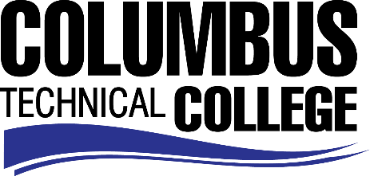

Position Announcement

Position: Federal Work Study Student – Mathematics Test Proctor
Location: Financial Aid Department
Nature of Duties: The Math Test Proctor is responsible for ensuring proper testing
procedures are followed.

Major duties will include:
- Check Student IDs and issue calculators to students in exchange for their ID
- Assign seats to testing students and input the test password
- Serve as a proctor ensuring security of examination procedures
- Ensure return receipt and proper storage of test materials such as calculators
- Troubleshoot computer login issues for students

Minimum Qualifications:
- Be enrolled as a student at Columbus Technical College
- Completed a FAFSA and be identified as being eligible for federal aid
- Complete a Federal Work-Study Employment Application

Preferred Qualifications:
- Successful completion of a math class at Columbus Technical College using MyMathLab software
- Flexible hours of availability up to 20 hours per week

Salary/Benefits: $7.50 per hour; no benefits
Method of Application: Interested candidates must complete electronic application process at www.columbustech.edu, CTC Careers, Federal Work Study. Application Deadline is July 4, 2019.
Employment Policy: The Technical College System of Georgia and its constituent Technical Colleges do not discriminate on the basis of race, color, creed, national or ethnic origin, gender, religion, disability, age, political affiliation or belief, genetic information, disabled veteran, veteran of the Vietnam Era, spouse of military member or citizenship status (except in those special circumstances permitted or mandated by law). This nondiscrimination policy encompasses the operation of all technical college-administered programs, programs financed by the federal government including any Workforce Investment Act of 1998 (WIA) Title I financed programs, educational programs and activities, including admissions, scholarships and loans, student life, and athletics. It also encompasses the recruitment and employment of personnel and contracting for goods and services.

The Technical College System of Georgia and its colleges shall promote the realization of equal opportunity through a positive continuing program of specific practices. The following persons have been designated to handle inquiries regarding the nondiscrimination policies for Columbus Technical College: Henry Gross, Title IX Coordinator, at 706.649.1883 and Olive Vidal-Kendall, Section 504 Coordinator, at 706.649.1442.

