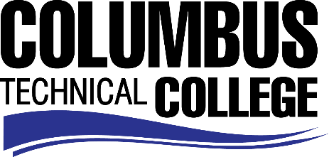

Position Announcement

Funeral Service Education Adjunct Clinical Instructor
Columbus Technical College is seeking an individual to serve as an adjunct Clinical Instructor for the Funeral Services Education Program. This individual will assist faculty in conducting practicum visits at designated clinical sites. This position is part-time/exempt.

Responsibilities:
- Assist funeral service faculty in conducting practicum visits at designated clinical sites in Georgia.’
- Attend staff development training, workshops, or seminars;
- Ensures safety and security requirements are met in the training area;
Minimum Qualifications
- Candidate must be a graduate of a Funeral Service program accredited by the American Board of Funeral Service Education (ABFSE).
- Must have a current Georgia Funeral Director’s license and a current Georgia Embalmer’s license.
- Bachelor’s degree
- Work experience in the funeral service industry in the last 3 years
Preferred Qualifications
- Proven ability to work independently in the preparation/embalming room
- Duties associated with a licensed funeral director
Salary/Benefits
Salary is commensurate with education and experience.
Application Deadline
Position is available until filled. Applicants must submit a Columbus Technical College employment application online at www.columbustech.edu CTC Employment, and upload a cover letter, resume, and official copy of transcript(s) at time of application (Incomplete submissions will not be considered). Background check is required.
Employment Policy
The Technical College System of Georgia and its constituent Technical Colleges do not discriminate on the basis of race, color, creed, national or ethnic origin, gender, religion, disability, age, political affiliation or belief, genetic information, disabled veteran, veteran of the Vietnam Era, spouse of military member or citizenship status (except in those special circumstances permitted or mandated by law). This nondiscrimination policy encompasses the operation of all technical college-administered programs, programs financed by the federal government including any Workforce Investment Act of 1998 (WIA) Title I financed programs, educational programs and activities, including admissions, scholarships and loans, student life, and athletics. It also encompasses the recruitment and employment of personnel and contracting for goods and services.
The Technical College System of Georgia and its colleges shall promote the realization of equal opportunity through a positive continuing program of specific practices. The following person has been designated to handle inquiries regarding the nondiscrimination policies for Columbus Technical College: Patricia Hood, Executive Director of Human Resources and Title IX and Section 504 Coordinator, 928 Manchester Expressway, Columbus, GA 31904 or 706-649-1883.

