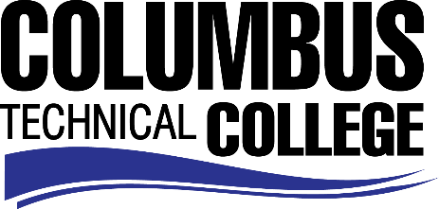

Position Announcement

Adjunct Instructor –History
Columbus Technical College is seeking an individual to serve as an adjunct instructor for History. Under general supervision, this individual will prepare lesson plans for classroom instruction, and evaluate students’ progress in attaining goals, objectives, and student learning outcomes. This position is part-time/non-exempt.
Responsibilities:
- Prepares lesson plans for classroom instruction
- Act as primary science lab instructor on weekly basis
- Develops program and course outlines, goals and objectives
- Evaluate students’ progress in attaining goals and objectives
- Request and maintain supplies, tools, and equipment, and prepare budget requests
- Maintain program certification requirements, as appropriate
- Prepares and maintains all required documentation and administrative reports
- Maintains knowledge of current trends and developments in the field by attending staff development training, workshops, seminars and conferences and by reading professional literature
- Ensures safety and security requirements are met in the training area
- Meets with students, staff members and other educators to discuss students' instructional programs and other issues impacting the progress of the students
- Assists with recruitment, retention and job placement efforts
Minimum Qualifications
- A Master’s Degree from a regionally accredited college or university in History (or a related field)
OR
- A Master’s Degree from a regionally accredited college or university with a minimum of 18 graduate semester hours or 27 graduate quarter hours in History.
Salary/Benefits
Salary is commensurate with education and experience.
Application Deadline
This position is available until filled. Applicants must submit a Columbus Technical College employment application online at www.columbustech.edu CTC Employment, and upload a cover letter, resume, and copy of official transcript(s) at time of application (Incomplete submissions will not be considered). Background check is required.
Employment Policy
The Technical College System of Georgia and its constituent Technical Colleges do not discriminate on the basis of race, color, creed, national or ethnic origin, gender, religion, disability, age, political affiliation or belief, genetic information, disabled veteran, veteran of the Vietnam Era, spouse of military member or citizenship status (except in those special circumstances permitted or mandated by law). This nondiscrimination policy encompasses the operation of all technical college-administered programs, programs financed by the federal government including any Workforce Investment Act of 1998 (WIA) Title I financed programs, educational programs and activities, including admissions, scholarships and loans, student life, and athletics. It also encompasses the recruitment and employment of personnel and contracting for goods and services.

The Technical College System of Georgia and its colleges shall promote the realization of equal opportunity through a positive continuing program of specific practices. The following person has been designated to handle inquiries regarding the nondiscrimination policies for Columbus Technical College: Patricia Hood, Executive Director of Human Resources and Title IX and Section 504 Coordinator, 928 Manchester Expressway, Columbus, GA 31904 or 706-649-1883.

