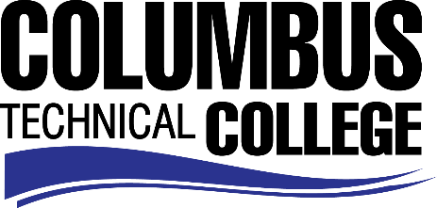

Position Announcement

History Adjunct Instructor
Columbus Technical College is seeking an individual to serve as an adjunct instructor for History. Under general supervision, this individual will prepare lesson plans for classroom instruction; evaluate students’ progress in attaining goals, objectives, and student learning outcomes; academically advise students; attend faculty development training, workshops, seminars, and conferences as needed. Further requirements include assisting with recruitment, retention, job placement efforts, and sustaining a credible advisory board for the program. This position requires day, evening, and on-line instruction.
Responsibilities:
- Delivers effective individualized program and instruction to class members
- Ensures adherence to technical college and safety requirements in classrooms and labs by following established procedures
- Selects and obtains appropriate educational materials for courses
- Ensures consistency in syllabi, lesson plans, test, and other appropriate course work
- Monitors use of and maintains supplies, equipment and/or facilities for assigned program.
- Assists with recruiting and marketing activities
- Assists with registration and orientation functions
- Participates in standing or ad hoc committee meetings relating to curriculum development, extra curricula activities, and other technical college sponsored activities or programs as required
- Assists with the design and execution of special events, projects and activities as requested
- Displays a high level of effort and commitment to performing work; operates effectively within the organizational structure; demonstrates trustworthiness and responsible behavior.
Minimum Qualifications
- A Master’s Degree from an accredited institution in the teaching discipline (i.e. History)
-OR-
- A Master’s Degree from an accredited institution with a concentration in the teaching discipline (minimum 18 graduate semester hours or 27 graduate quarter hours required in teaching discipline).
Preferred Qualifications
In addition to the minimum qualifications, one or more years of experience with instruction in a postsecondary setting, experience with learning management systems.
Salary/Benefits
Salary is commensurate with education and experience.

Application Deadline
Applications are accepted until position is filled. Applicants must submit a Columbus Technical College employment application online at www.columbustech.edu CTC Employment, and upload a cover letter, resume, and copy of official transcript(s) at time of application (Incomplete submissions will not be considered). Background check is required.
Employment Policy
The Technical College System of Georgia and its constituent Technical Colleges do not discriminate on the basis of race, color, creed, national or ethnic origin, gender, religion, disability, age, political affiliation or belief, genetic information, disabled veteran, veteran of the Vietnam Era, spouse of military member or citizenship status (except in those special circumstances permitted or mandated by law). This nondiscrimination policy encompasses the operation of all technical college-administered programs, programs financed by the federal government including any Workforce Investment Act of 1998 (WIA) Title I financed programs, educational programs and activities, including admissions, scholarships and loans, student life, and athletics. It also encompasses the recruitment and employment of personnel and contracting for goods and services.

The Technical College System of Georgia and its colleges shall promote the realization of equal opportunity through a positive continuing program of specific practices. The following person has been designated to handle inquiries regarding the nondiscrimination policies for Columbus Technical College: Patricia Hood, Executive Director of Human Resources and Title IX and Section 504 Coordinator, 928 Manchester Expressway, Columbus, GA 31904 or 706-649-1883.

