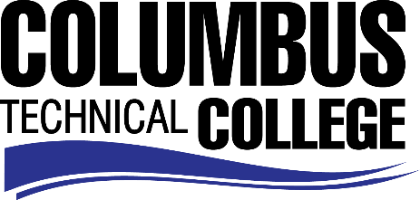

Position Announcement

Interpreter (Part-time)
Columbus Technical College is seeking an individual to serve as an Interpreter for our Student Affairs Division. This individual will be responsible for providing interpretation/translation for deaf and hard of hearing students. This position may require day and/or night time work hours.

Responsibilities:

- Provides interpreting/transliterating in the classroom, for meetings, registration, testing, tutoring, counseling, etc., for deaf and hard of hearing students;
- Provides academic advising to deaf and hard of hearing students;
- Confers and plans with students, teachers and other interpreters in preparation for assignments;
- Assists in developing and presenting training programs and providing workshops for part-time interpreters, students, faculty and staff.
- Notifies the office of Disability Services of all issues related to the classroom and academic performance of students.
- Decision making and problem solving skills
- Skill in the operation of computers and job related software programs
- Skill in interpersonal relations and in dealing with the public
- Ability to work independently with minimal supervision
- Ability to communicate in a concise and effective manner
- Ability to understand and follow instructions precisely
- Ability to interpret and translate college-level classes

Minimum Qualifications

- High School Diploma
- Minimum 2 years of related work experience

Preferred Qualifications (In addition to minimum requirements)

- Minimum 3 years’ work experience as an Interpreter for the deaf/hard of hearing in an educational environment
- Qualified or Certified as an Interpreter

Salary/Benefits
Pay is $30 per hour, no benefits
Application Deadline
Position available until January 30, 2019. Applicants must submit a Columbus Technical College employment application online at www.columbustech.edu CTC Careers, and upload a cover letter, resume, and copy of official transcript(s) at time of application (Incomplete submissions will not be considered). **Please note: All references will be checked prior to employment offer. Post offer requirements will include a criminal background check and motor vehicle records check. **

Employment Policy
The Technical College System of Georgia and its constituent Technical Colleges do not discriminate on the basis of race, color, creed, national or ethnic origin, gender, religion, disability, age, political affiliation or belief, genetic information, disabled veteran, veteran of the Vietnam Era, spouse of military member or citizenship status (except in those special circumstances permitted or mandated by law). This nondiscrimination policy encompasses the operation of all technical college-administered programs, programs financed by the federal government including any Workforce Investment Act of 1998 (WIA) Title I financed programs, educational programs and activities, including admissions, scholarships and loans, student life, and athletics. It also encompasses the recruitment and employment of personnel and contracting for goods and services.

The Technical College System of Georgia and its colleges shall promote the realization of equal opportunity through a positive continuing program of specific practices. The following person has been designated to handle inquiries regarding the nondiscrimination policies for Columbus Technical College: Patricia Hood, Executive Director of Human Resources and Title IX and Section 504 Coordinator, 928 Manchester Expressway, Columbus, GA 31904 or 706-649-1883.

