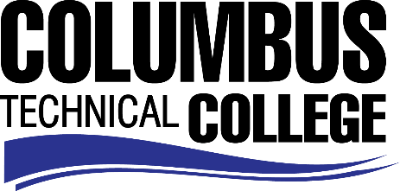

Position Announcement

Librarian Part-Time
Columbus Technical College Library is seeking a part-time librarian to work with students, faculty, and staff. The position has responsibility for managing and/or assisting in the provision of services to faculty, staff, and community patrons to include: circulation; in-person reference; virtual assistance (chat and email); access control; broad support for all aspects of library systems, software and technology, including the integrated library system. This position is part-time/non-exempt and the hours are on an as needed basis.
Responsibilities:
- Supervises and directs, assigned clerical part-time staff;
- Manages petty cash funds;
- Assists with or completes employee performance appraisals;
- Directs work and trains staff in operations, policies, and procedures;
- Share instructional class assignments that provide instruction to students, faculty, and staff on effective use of library resources, annotated bibliographies, citation management tools, and reference and research in program areas.
- Services will be provided to on-campus, off-campus, and online patrons.
Minimum Qualifications
- Master’s degree in Library and Information Science from an American Library Association (ALA) accredited institution
Preferred Qualifications
- Media Specialist with Master’s Degree and 3 years of library work experience
Salary/Benefits
Pay rate is $20 per hour, no benefits
Application Deadline
Applications accepted through June 25, 2019. Applicants must submit a Columbus Technical College employment application online at: https://www.easyhrweb.com/JC_Columbus/JobListings/JobListings.aspx and upload a cover letter, resume and copy of transcript(s) at time of application (Incomplete submissions will not be considered). **Please note: All references will be checked prior to employment offer. Post offer requirements will include a criminal background check and motor vehicle records check. **
Employment Policy
The Technical College System of Georgia and its constituent Technical Colleges do not discriminate on the basis of race, color, creed, national or ethnic origin, gender, religion, disability, age, political affiliation or belief, genetic information, disabled veteran, veteran of the Vietnam Era, spouse of military member or citizenship status (except in those special circumstances permitted or mandated by law). This nondiscrimination policy encompasses the operation of all technical college-administered programs, programs financed by the federal government including any Workforce Investment Act of 1998 (WIA) Title I financed programs, educational programs and activities, including admissions, scholarships and loans, student life, and athletics. It also encompasses the recruitment and employment of personnel and contracting for goods and services.

The Technical College System of Georgia and its colleges shall promote the realization of equal opportunity through a positive continuing program of specific practices. The following persons have been designated to handle inquiries regarding the nondiscrimination policies for Columbus Technical College: Henry Gross, Title IX Coordinator, at 706.649.1883 and Olive Vidal-Kendall, Section 504 Coordinator, at 706.649.1442.

