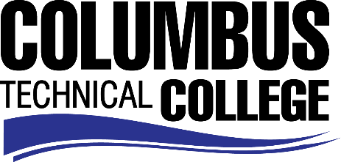

Position Announcement

Instructional Aide – Machine Tool Technology Program (Part-time)
Columbus Technical College is seeking an individual to serve as a part-time Instructional Aide in our Machine Tool Technology Department. This individual will assist instructors with providing education and/or training to CTC students. This position is part-time/non-exempt.
Responsibilities:
- Assist instructor with classroom presentations
- Assist instructor in maintaining an effective learning environment
- Complete documentation of student progress
- Perform various types of clerical tasks to assist instructor
- Prepares materials, exhibits, equipment and demonstrations
- Requests and maintains assigned classroom supplies, materials, and equipment
- Tutors and assists individual students in the learning environment
- Assist students and instructor in the lab learning activities associated with Computer Aided Drafting
- Excellent written and oral communication skills
- Other job related duties as assigned
Minimum Qualifications
- High School Diploma or GED
- Minimum of 6 months recent in field work experience with machine tool field.
Salary
Salary is commensurate with education and experience.
Application Deadline
Position is available until filled. Applicants must submit a Columbus Technical College employment application online at www.columbustech.edu CTC Employment, and upload a cover letter, resume, and copy of High School Diploma or GED and/or any college transcripts at time of application (Incomplete submissions will not be considered). Background check is required.
Employment Policy
The Technical College System of Georgia and its constituent Technical Colleges do not discriminate on the basis of race, color, creed, national or ethnic origin, gender, religion, disability, age, political affiliation or belief, genetic information, disabled veteran, veteran of the Vietnam Era, spouse of military member or citizenship status (except in those special circumstances permitted or mandated by law). This nondiscrimination policy encompasses the operation of all technical college-administered programs, programs financed by the federal government including any Workforce Investment Act of 1998 (WIA) Title I financed programs, educational programs and activities, including admissions, scholarships and loans, student life, and athletics. It also encompasses the recruitment and employment of personnel and contracting for goods and services.

The Technical College System of Georgia and its colleges shall promote the realization of equal opportunity through a positive continuing program of specific practices. The following person has been designated to handle inquiries regarding the nondiscrimination policies for Columbus Technical College: Patricia Hood, Executive Director of Human Resources and Title IX and Section 504 Coordinator, 928 Manchester Expressway, Columbus, GA 31904 or 706-649-1883.

