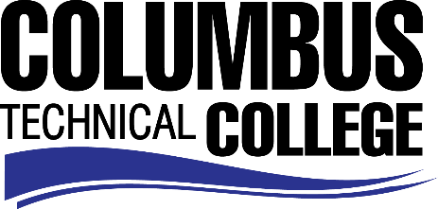

Position Announcement

Major Appliance Repair Technical Instructor – Full-time
Columbus Technical College is seeking an individual to serve as an instructor in the Major Appliance Repair Technology Division. Under general supervision, this individual will prepare lesson plans for classroom instruction, and evaluate students’ progress in attaining goals, objectives, and student learning outcomes. This position requires day, afternoon, and evening instruction. This position is full-time/exempt.
Responsibilities:
- Instruct students in Major Appliance Technology skill areas
- Follow state standards in developing program and course outlines, goals and objectives
- Evaluate students’ progress in attaining goals and objectives
- Maintain supplies, tools, and equipment
- Maintain management procedures and documentation
- Ensure safety and security requirements are met in the training areas
- Respond in a timely manner to administrative requests
- Assist with recruitment, retention, and job placement efforts
- Strong time management and organization skills
- Effective written and oral communication
- Keen observation, supervision and evaluation skills
- General Computer knowledge (Microsoft Office, Outlook, Word)
- Other job related duties as assigned
Minimum Qualifications
- An Associate Degree from a regionally accredited college or university *and* a minimum of 3 years work experience in the Appliance Repair field.
-OR-
- A Diploma in Major Appliance Technology from an accredited college or technical institution*and* a minimum of 3 years work experience in the Appliance Repair field.
Salary/Benefits
Salary is commensurate with education and experience. Benefits include state holidays, annual leave, and sick leave, State of Georgia Retirement, Health and Flexible Benefits Program.

Application Deadline
Applications accepted through August 21, 2019. Applicants must submit a Columbus Technical College employment application online at: https://www.easyhrweb.com/JC_Columbus/JobListings/JobListings.aspx and upload a cover letter, resume and copy of transcript(s) at time of application (Incomplete submissions will not be considered). **Please note: All references will be checked prior to employment offer. Post offer requirements will include a criminal background check and motor vehicle records check. **

Employment Policy
The Technical College System of Georgia and its constituent Technical Colleges do not discriminate on the basis of race, color, creed, national or ethnic origin, gender, religion, disability, age, political affiliation or belief, genetic information, disabled veteran, veteran of the Vietnam Era, spouse of military member or citizenship status (except in those special circumstances permitted or mandated by law). This nondiscrimination policy encompasses the operation of all technical college-administered programs, programs financed by the federal government including any Workforce Investment Act of 1998 (WIA) Title I financed programs, educational programs and activities, including admissions, scholarships and loans, student life, and athletics. It also encompasses the recruitment and employment of personnel and contracting for goods and services.

The Technical College System of Georgia and its colleges shall promote the realization of equal opportunity through a positive continuing program of specific practices. The following persons have been designated to handle inquiries regarding the nondiscrimination policies for Columbus Technical College: Henry Gross, Title IX Coordinator, at 706.649.1883 and Olive Vidal-Kendall, Section 504 Coordinator, at 706.649.1442.

