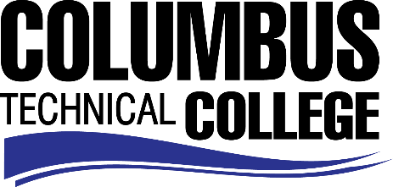

Position Announcement

Physical Therapy Assistant Instructor/Program Director
Columbus Technical College is seeking an individual to serve as an instructor for the Physical Therapy Assistant Program. This individual will be responsible for classroom, laboratory and clinical instruction along with preparation of lesson plans for classroom, lab, and the clinical setting. This position will also require evaluation of student progress in attaining goals and objectives; attend staff development training, workshops, seminars, and conferences, and ensure all safety and security requirements are met in trainings.

Responsibilities:
- Prepares and plans for instruction and delivers instruction to students in the Physical Therapy Assistant Program
- Develops program syllabi, goals and objectives;
- Evaluates students' progress in attaining goals and objectives;
- Requests and maintains supplies and equipment and prepares budget requests;
- Prepares and maintains all required documentation and administrative reports;
- Ensures safety and security requirements are met in the training area;
- Meets with students, staff members and other educators to discuss students' instructional program and other issues;
- Assists with recruitment, retention and job placement efforts.
- Contribute to the writing of accreditation and assessment reports
- Attain accreditation through COMMISSION ON ACCREDITATION IN PHYSICAL THERAPY EDUCATION (CAPTE)
Minimum Qualifications
- Master’s degree or higher from a regionally accredited college or university.
- Must hold a current license/certification to practice as a Physical Therapist or Physical Therapist Assistant in any United States jurisdiction
- A minimum of five years (or equivalent), full-time, post licensure experience that includes a minimum of three years (or equivalent) of full-time clinical experience; didactic and/or clinical teaching experience
- Excellent human-relations, interpersonal skills, and strong verbal and written communication skills required.

Salary/Benefits
Salary is commensurate with education and experience. Benefits include state holidays, annual leave, and sick leave, State of Georgia Retirement, Health and Flexible Benefits Program.
Application Deadline
Position will be open until filled. Applicants must submit a Columbus Technical College employment application online at www.columbustech.edu CTC Employment, and upload a cover letter, resume, and official copy of transcript(s) at time of application (Incomplete submissions will not be considered). Background check is required.
Employment Policy
The Technical College System of Georgia and its constituent Technical Colleges do not discriminate on the basis of race, color, creed, national or ethnic origin, gender, religion, disability, age, political affiliation or belief, genetic information, disabled veteran, veteran of the Vietnam Era, spouse of military member or citizenship status (except in those special circumstances permitted or mandated by law). This nondiscrimination policy encompasses the operation of all technical college-administered programs, programs financed by the federal government including any Workforce Investment Act of 1998 (WIA) Title I financed programs, educational programs and activities, including admissions, scholarships and loans, student life, and athletics. It also encompasses the recruitment and employment of personnel and contracting for goods and services.
The Technical College System of Georgia and its colleges shall promote the realization of equal opportunity through a positive continuing program of specific practices. The following person has been designated to handle inquiries regarding the nondiscrimination policies for Columbus Technical College: Patricia Hood, Executive Director of Human Resources and Title IX and Section 504 Coordinator, 928 Manchester Expressway, Columbus, GA 31904 or 706-649-1883.

