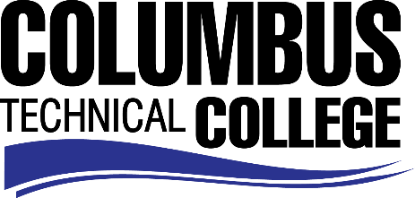

Position Announcement

Service Industry Academy (SIA) Part-time Instructor
Columbus Technical College is seeking an individual to serve as a part-time Instructor for our Service Industry Academy. This instructor will administer and teach classes in the Service Industry Academy (SIA) programs for credit and non-credit classes. SIA programs consist of Certified Customer Service Specialist. This position will require teaching in campus classrooms, Industrial Field, High School settings, and ability to travel within Muscogee, Harris, Talbot, Chattahoochee, Stewart, and Quitman counties. Position is part-time/exempt.
Responsibilities:
- Administer and teach classes in the Service Industry Academy (SIA) programs for credit and non-credit classes
- Facilitate classroom environment;
- Teach interpersonal skills in a High School setting;
- Adaptable to an environment with various ages;
- Prepares lesson plans for classroom instruction and obtains or prepares instructional materials for classroom use;
- Develops program and course outlines, goals and objectives;
- Evaluates students’ ongoing progress and performance in attaining goals and objectives;
- Requests and maintains supplies and equipment;
- Maintains program certification requirements;
- Prepares and maintains all required documentation and administrative reports
- Maintains a secure classroom environment;
- Ensures safety and security requirements are met in the training area.

Minimum Qualifications
- A Bachelor’s degree in Marketing.
- Minimum three (3) years’ experience within Marketing and Customer Service Field.
Salary/Benefits
Salary is commensurate with education and experience.
Application Deadline
This position is available until filled. Applicants must submit a Columbus Technical College employment application online at www.columbustech.edu CTC Employment, and upload a cover letter, resume, and copy of an official transcript(s)at time of application (Incomplete submissions will not be considered). Background Check is required.
Employment Policy
The Technical College System of Georgia and its constituent Technical Colleges do not discriminate on the basis of race, color, creed, national or ethnic origin, gender, religion, disability, age, political affiliation or belief, genetic information, disabled veteran, veteran of the Vietnam Era, spouse of military member or citizenship status (except in those special circumstances permitted or mandated by law). This nondiscrimination policy encompasses the operation of all technical college-administered programs, programs financed by the federal government including any Workforce Investment Act of 1998 (WIA) Title I financed programs, educational programs and activities, including admissions, scholarships and loans, student life, and athletics. It also encompasses the recruitment and employment of personnel and contracting for goods and services.

The Technical College System of Georgia and its colleges shall promote the realization of equal opportunity through a positive continuing program of specific practices. The following person has been designated to handle inquiries regarding the nondiscrimination policies for Columbus Technical College: Patricia Hood, Executive Director of Human Resources and Title IX and Section 504 Coordinator, 928 Manchester Expressway, Columbus, GA 31904 or 706-649-1883.

