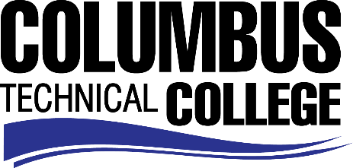

Position Announcement

Sign Language Adjunct Instructor
Columbus Technical College is seeking an individual to serve as a part-time Sign Language Adjunct instructor in Economic Development Division. This individual will be responsible for providing lectures, exercises and drills to communicate through American Sign Language. This position is part-time/exempt.

Responsibilities:
- Facilitate classes and ensure safe classroom environment
- Creates and maintains class records (enrollment, completion, invoices, etc.)
- Oversee exercises, drills, and exams, if applicable
- Registers students
- Monitors students’ progress
- Prepares and sends correspondences to students with class details and final results of skills
- Advisement of students on enhancing sign language skills

Minimum Qualifications
- Three (3) years or more of work experience in the American Sign Language field.
Preferred Qualifications
- Certification or training in American Sign Language
Salary/Benefits
Pay rate is $25 per hour, no benefits.
Application Deadline
Applications accepted through August 31, 2019. Applicants must submit a Columbus Technical College employment application online at: https://www.easyhrweb.com/JC_Columbus/JobListings/JobListings.aspx and upload a cover letter, resume and copy of transcript(s) at time of application (Incomplete submissions will not be considered). **Please note: All references will be checked prior to employment offer. Post offer requirements will include a criminal background check and motor vehicle records check. **
Employment Policy
The Technical College System of Georgia and its constituent Technical Colleges do not discriminate on the basis of race, color, creed, national or ethnic origin, gender, religion, disability, age, political affiliation or belief, genetic information, disabled veteran, veteran of the Vietnam Era, spouse of military member or citizenship status (except in those special circumstances permitted or mandated by law). This nondiscrimination policy encompasses the operation of all technical college-administered programs, programs financed by the federal government including any Workforce Investment Act of 1998 (WIA) Title I financed programs, educational programs and activities, including admissions, scholarships and loans, student life, and athletics. It also encompasses the recruitment and employment of personnel and contracting for goods and services.

The Technical College System of Georgia and its colleges shall promote the realization of equal opportunity through a positive continuing program of specific practices. The following persons have been designated to handle inquiries regarding the nondiscrimination policies for Columbus Technical College: Henry Gross, Title IX Coordinator, at 706.649.1883 and Olive Vidal-Kendall, Section 504 Coordinator, at 706.649.1442.

