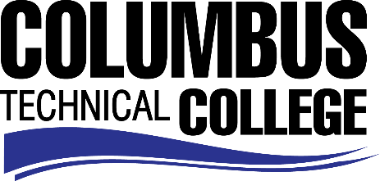

Position Announcement

Student Affairs Assistant/Admissions – Part-time
Columbus Technical College is seeking an individual to serve as a part-time Student Affairs Assistant for our Admissions office. This individual will be responsible for performing administrative and clerical duties in support of the Student Affairs Division. This position is part-time/non-exempt.
Responsibilities:
- Provide secretarial and clerical duties in support of the student services program;
- Enter data from forms, records and/or reports using BANNER software or onto appropriate websites;
- Codes information as appropriate;
- Greets visitors and/or students and determines the nature of the business and provides appropriate information or refers to appropriate personnel;
- Maintains calendars and schedules appointments, meetings and conferences;
- Assists with special event planning and execution;
- Assist with coordination of campus visits and assists with group tours as needed;
- Assists with recruiting and marketing activities;
- Assists with registration functions;
- Assists with the design and execution of special events, projects and activities as requested.
Minimum Qualifications
- High School graduate or equivalent *and* Six (6) months of related work experience.
Preferred Qualifications
- Associate Degree or one year of administrative work experience.
Salary/Benefits
Pay rate is $10 per hour with no benefits

Application Deadline
Applications accepted through June 13, 2019. Applicants must submit a Columbus Technical College employment application online at: https://www.easyhrweb.com/JC_Columbus/JobListings/JobListings.aspx and upload a cover letter, resume and copy of transcript(s) at time of application (Incomplete submissions will not be considered). **Please note: All references will be checked prior to employment offer. Post offer requirements will include a criminal background check and motor vehicle records check. **
Employment Policy
The Technical College System of Georgia and its constituent Technical Colleges do not discriminate on the basis of race, color, creed, national or ethnic origin, gender, religion, disability, age, political affiliation or belief, genetic information, disabled veteran, veteran of the Vietnam Era, spouse of military member or citizenship status (except in those special circumstances permitted or mandated by law). This nondiscrimination policy encompasses the operation of all technical college-administered programs, programs financed by the federal government including any Workforce Investment Act of 1998 (WIA) Title I financed programs, educational programs and activities, including admissions, scholarships and loans, student life, and athletics. It also encompasses the recruitment and employment of personnel and contracting for goods and services.

The Technical College System of Georgia and its colleges shall promote the realization of equal opportunity through a positive continuing program of specific practices. The following persons have been designated to handle inquiries regarding the nondiscrimination policies for Columbus Technical College: Henry Gross, Title IX Coordinator, at 706.649.1883 and Olive Vidal-Kendall, Section 504 Coordinator, at 706.649.1442.

