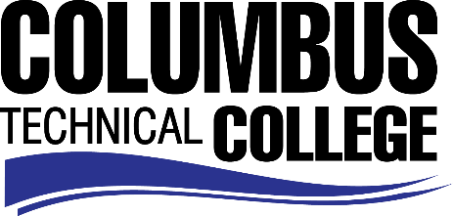

Position Announcement

Testing Specialist- Part-time
Columbus Technical College is seeking an individual to serve as a part-time Testing Specialist in Economic Development Department. This individual will be responsible for providing testing and testing services to customers. This position is part-time/non-exempt.

Responsibilities:
- Proctors various academic, distance learning, exemption and nationally recognized college exams to ensure test security
- Creates and maintains Assessment Databases
- Data entry of students’ scores into appropriate student database system
- Maintains appropriate test administrator certifications
- Oversees exam software installation, maintenance and upgrades
- Registers students for exams
- Monitors daily exam schedule
- Maintains exam files
- Prepares and sends correspondences to other colleges, instructors, and testing agents
- Communicates exam scores to students
- Advisement of students on test scores, next steps and registration
- Creates site, incident and irregularity reports
- Develops Assessment Training materials

Minimum Qualifications
- Associate Degree *and* Three (3) years of work related experience
Note: Experience may substitute for the degree on a year-for-year basis.
Preferred Qualifications
- Two (2) years of work experience proctoring exams within an educational environment.
Salary/Benefits
Salary is commensurate with education and experience.
Application Deadline
For consideration, applications should be received by January 30, 2018. Applicants must submit a Columbus Technical College employment application online at www.columbustech.edu CTC Employment, and upload a cover letter, resume and official transcripts at time of application (Incomplete submissions will not be considered).Background check is required.
Employment Policy
The Technical College System of Georgia and its constituent Technical Colleges do not discriminate on the basis of race, color, creed, national or ethnic origin, sex, religion, disability, age, political affiliation or belief, genetic information, disabled veteran, veteran of the Vietnam Era, spouse of military member or citizenship status (except in those special circumstances permitted or mandated by law). This nondiscrimination policy encompasses the operation of all technical college-administered programs, programs financed by the federal government including any Workforce Innovation and Opportunity Act (WIOA) Title I financed programs, educational programs and activities, including admissions, scholarships and loans , student life, and athletics. It also encompasses the recruitment and employment of personnel and contracting for goods and services.
The Technical College System and Technical Colleges shall promote the realization of equal opportunity through a positive continuing program of specific practices designed to ensure the full realization of equal opportunity. The following person has been designated to handle inquiries regarding the nondiscrimination policies for Columbus Technical College: Patricia Hood, Executive Director of Human Resources and Title IX and Section 504 Coordinator, 928 Manchester Expressway, Columbus, GA 31904 or 706-649-1883.

