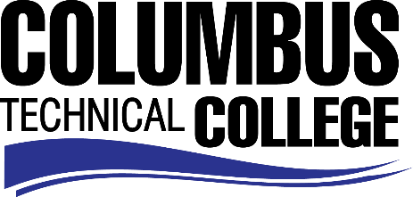

Position Announcement

Writing Support Lab Tutor Part-time
Columbus Technical College is seeking an individual to serve as a part-time Tutor in our Student Writing Support Lab. This individual will also be responsible for tutoring the student learner or a small group of learners in various areas of writing depending on the course of study. This is a part-time, non-exempt position.
Responsibilities:
- Complete tutor training through the Columbus Technical College Writing Support Lab
- Perform as part of a team striving to increase student success rates in English courses at the college
- Submit precise paperwork in a timely manner
- Provide one-on-one writing tutoring and assistance to students served by the Writing Support Lab
- Attend training sessions at the Writing Support Lab
- Maintain honest and accurate records while tracking the progress of students who use the center
- Assist the Writing Center Coordinator in planning and executing faculty development workshops
- Committee assignments and working on projects with other Academic Affairs and Student Services Personnel
- Perform other duties as necessary
Minimum Qualifications
- Current technical college student with an overall GPA of 3.0 and a minimum GPA of 3.0 in Writing
-OR-
- An outside applicant that demonstrates the ability and experience in the subject field and has documented tutoring or teaching.

Salary/Benefits
Pay rate is $10.00/hr.
Application Deadline
Applications accepted through January 30, 2019. Applicants must submit a Columbus Technical College employment application online at: https://www.easyhrweb.com/JC_Columbus/JobListings/JobListings.aspx and upload a cover letter, resume and copy of transcript(s) at time of application (Incomplete submissions will not be considered). **Please note: All references will be checked prior to employment offer. Post offer requirements will include a criminal background check and motor vehicle records check. **
Employment Policy
The Technical College System of Georgia and its constituent Technical Colleges do not discriminate on the basis of race, color, creed, national or ethnic origin, gender, religion, disability, age, political affiliation or belief, genetic information, disabled veteran, veteran of the Vietnam Era, spouse of military member or citizenship status (except in those special circumstances permitted or mandated by law). This nondiscrimination policy encompasses the operation of all technical college-administered programs, programs financed by the federal government including any Workforce Investment Act of 1998 (WIA) Title I financed programs, educational programs and activities, including admissions, scholarships and loans, student life, and athletics. It also encompasses the recruitment and employment of personnel and contracting for goods and services.

The Technical College System of Georgia and its colleges shall promote the realization of equal opportunity through a positive continuing program of specific practices. The following persons have been designated to handle inquiries regarding the nondiscrimination policies for Columbus Technical College: Madelyn Brown, Title IX Coordinator, at 706.649.1870 and Olive Vidal-Kendall, Section 504 Coordinator, at 706.649.1442.

