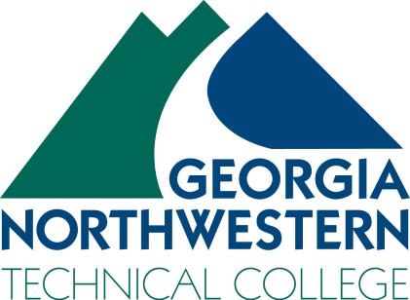 | Driver’s Education Instructor  Part-Time

Georgia Northwestern Technical College is seeking Instructors for the Part-time position of Drivers Education Training Instructor for the Continuing Education Department on the Floyd, Walker, Whitfield/Murray, and Catoosa County Campuses. This position is part-time/hourly and does not include benefits.

The Drivers Education Instructor will teach Driver Education classes as according to Joshua’s Law and the requirements set forth by the Georgia Department of Driver Services (DDS) and the Governor’s Office of Highway Safety. Instructors will coordinate, teach and assist students in the classroom and over the road in developing skills necessary to obtain a Class D Driver’s License.

Conditions of Employment:

- Must become a certified Driver Training Instructor by successfully completing curriculum developed by the Georgia Department of Drivers Services (DDS) which includes on-line training and passing the Driver Training Instructor’s examination on the content of Joshua’s Law, the Teenage and Adult Driver Responsibility Act (TADRA) and the Georgia driver’s manual.
- Undergo a motor vehicle records check and meet the driving standards established in the Technical College System of Georgia (TCSG) Driver Qualification Procedure and accompanying DDS requirements.
- Undergo a state and national criminal history records check and meet the employment standards outlined in the TCSG Background Investigations Procedure and accompanying DDS requirements.
- Undergo a physical examination and be certified by the examining physician as meeting the requirements for service as a Driver Training Instructor.

Minimum Qualifications: Must be at least 21 years of age and possess a valid driver’s license and a GED or High School Diploma.

Preferred Qualifications: A background in driver’s education, which includes a combination of classroom and over-the-road instruction in the safe operation of a motor vehicle. POST (Peace Officers Standards Training) Certification or a Georgia Teacher’s Certification.

Application Process: All application packets MUST be completed via the GNTC Online Job Center at www.gntc.edu/about/employment/. We do not accept resumes, transcripts, etc. in any other format except through the Online Job Center. As a part of the application process, interested candidates will also be required to upload documents such as a resume, work reference contact information, and transcripts if applicable. Pursuant to college policy, a thorough background investigation, including a criminal history records check, shall be conducted on all candidates prior to being hired for any position with our college. No phone calls or emails please.

A Unit of the Technical College System of Georgia

Equal Opportunity Employer

Georgia Northwestern Technical College does not discriminate based on race, color, creed, national or ethnic origin, gender, religion, disability, age political affiliation or belief, veteran status, or citizenship status (except in those special circumstances permitted or mandated by law). Any violation or questions should be directed to Elizabeth Barksdale, Interim Director of Human Resources, Office I101a, One Maurice Culberson Drive, Rome, GA 30161, at 706-295-6959; Jan Lanier, Dean of Student Success & Title VI Director, Office A127C, One Maurice Culberson Drive, Rome, GA 30161 at 706-295-6908; Kevan Watkins, Director, Accessibility Services, Office A127E, One Maurice Culberson Drive, Rome, GA 30161 at 706-295-6517. Telephone numbers are accessible to persons who are deaf or hard of hearing through the Georgia Relay by dialing 711 or 1-800-255-0056 from a TTY/TDD.

