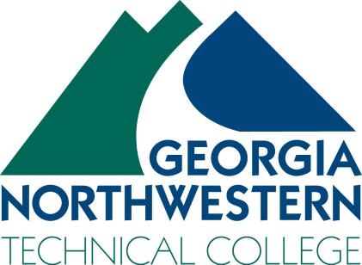 | Industrial Systems Technology Instructor  Floyd County Campus

Georgia Northwestern Technical College is seeking qualified applicants for the position of a full-time Industrial Systems Technology Program instructor on the Floyd County Campus for day, evening and online courses.

In addition to instruction, job duties will include ensuring lab equipment is secure and operable for student instruction prior to class; advise program director when instructional/lab supplies are needed; distribute lab supplies to students as needed during instruction; assist with maintaining an orderly and clean environment in the lab to ensure safety.

Required Qualifications: Diploma in Industrial Systems Technology or related discipline. Three years paid work experience in-field within the past seven years. Work experience must include the competencies, skills, and knowledge levels included in the Industrial Systems Technology instructional programs. Excellent organizational, communication, and interpersonal skills. Excellent technology and classroom management skills.

Preferred Qualifications: Associates degree in Industrial Systems. State of Georgia Class II Electrical Contractor License. Post-secondary teaching experience, curriculum development, and program recruitment experience in a two-year college environment.

Application Deadline: Position opened until filled.

Application Process: All application packets MUST be completed via the GNTC Online Job Center at www.GNTC.edu. We do not accept resumes, transcripts, etc. in any other format except through the Online Job Center. As a part of the application process, interested candidates will also be required to upload documents such as a resume, work reference contact information, and transcripts if applicable. Pursuant to college policy, a thorough background investigation, including a criminal history records check, shall be conducted on all candidates prior to being hired for any position with our college. No phone calls or emails please.

A Unit of the Technical College System of Georgia

Equal Opportunity Employer
Georgia Northwestern Technical College does not discriminate on the basis of race, color, creed, national or ethnic origin, gender, religion, disability, age political affiliation or belief, veteran status, or citizenship status (except in those special circumstances permitted or mandated by law). Any violation or questions should be directed to Peggy Cordell, Director of Human Resources, Office I101a, One Maurice Culberson Drive, Rome, GA 30161, at 706-295-6959; Sonya Briscoe, Special Populations Director and Title IV & Title IX Coordinator, Office A120a, One Maurice Culberson Drive, Rome, GA 30161 at 706-295-6932; Sheila Parker, ADA/Section 504 Coordinator and Disability Services Coordinator, Office B115, One Maurice Culberson Drive, Rome, GA 30161 at 706-295-6517. Telephone numbers are accessible to persons who are deaf or hard of hearing through the Georgia Relay by dialing 711 or 1-800-255-0056 from a TTY/TDD.

