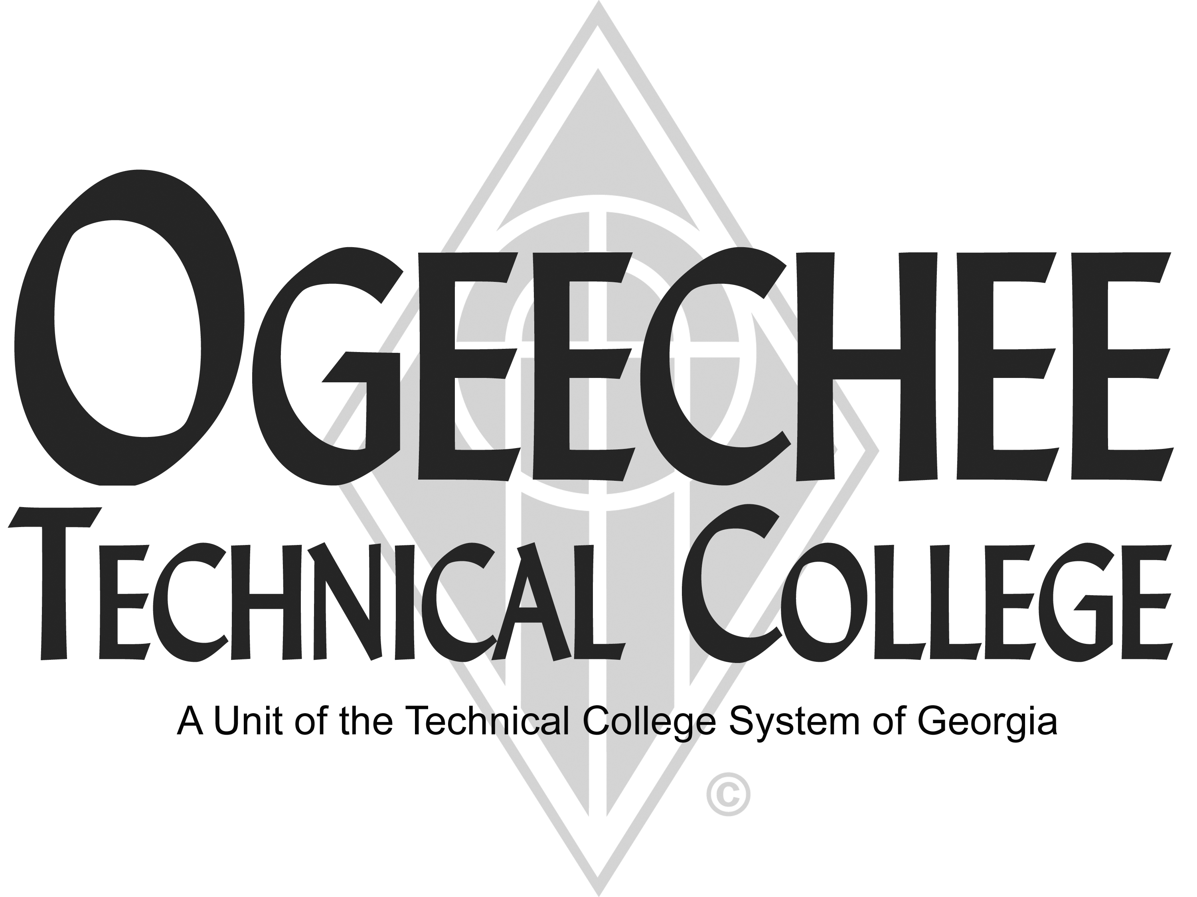

POSITION ANNOUNCEMENT



|  |  |
| --- | --- |
| **POSITION TITLE:** | **Adjunct Industrial Maintenance Technology Instructor** |
|  |  |
| **POSITION DESCRIPTION:** Under minimal supervision, is responsible for the delivery of industrial maintenance assessments and training through online curriculum and hands-on lab; participates in project studies to analyze and align industries with training needs; develops training plans; evaluates students’ progress in attainment of goals and objectives; maintains lab safety and cleanliness; ensures equipment is in proper working order; stays abreast of industry needs and makes recommendations to the Director; assists in the development of new course designs; produces reports as requested; and serves as a subject matter expert in the area of industrial maintenance.(NOTE: 10-15 hours per week; must be able to work flexible schedule to meet customer needs) | |
| **MINIMUM QUALIFICATIONS:**   * High School Diploma or Equivalent * Three years industry experience with industrial maintenance, including but not limited to, hydraulics, electrical, mechanical, pneumatics, PLC, machine tooling, CNC, etc. * Experience with the delivery of quality customer service * Basic computer skills including MS Word, Excel, and Outlook * Organization and communication skills   **PREFERRED QUALIFICATIONS:**   * Certification or higher in industrial maintenance related field. * Five or more years industry experience with industrial maintenance * Experience using Amatrol trainers * Recent teaching experience * Excellent verbal (face-to-face or phone) and nonverbal (e-mail) communication skills * Excellent organizational skills * One year experience in planning, developing, delivering, and/or evaluating training or academic programs * Supervisory experience | |
| **SALARY/BENEFITS:** Commensurate with qualifications. | |
| **APPLICATION DEADLINE:**  Open Until Filled | |
|  |  |
| **TO APPLY:** You can apply online at: http://www.ogeecheetech.edu/employment/cover_letter.cfm or submit an OTC application, cover letter, résumé, and three work-related references (should be previous supervisors). Official transcripts are required upon employment. Copies of all transcripts should be submitted at the time of application for faculty positions. A criminal history records/MVR check is required as a condition of employment. Submit materials to: Stephen Miller, Director of Human Resources, Ogeechee Technical College, One Joe Kennedy Blvd., Statesboro, GA 30458. Materials may also be submitted online or to employment@ogeecheetech.edu. | |
|  |  |
| As set forth in its student catalog, Ogeechee Technical College does not discriminate on the basis of race, color, creed, national or ethnic origin, gender, religion, disability, age, political affiliation or belief, genetic information, veteran status, or citizenship status (except in those special circumstances permitted or mandated by law). The following individuals have been designated to handle inquiries regarding the nondiscrimination policies: Kelli Waters, Title IX Coordinator, Ogeechee Technical College One Joseph E. Kennedy Blvd., Office 193, Joseph E. Kennedy Building, Statesboro, GA 30458, 912.871.1885, kwaters@ogeecheetech.edu and Penny Hendrix, ADA/Section 504 Coordinator, Ogeechee Technical College, One Joseph E. Kennedy Blvd., Office 189, Joseph E. Kennedy Building, Statesboro, GA 30458, 912.486.7211,phendrix@ogeecheetech.edu | |