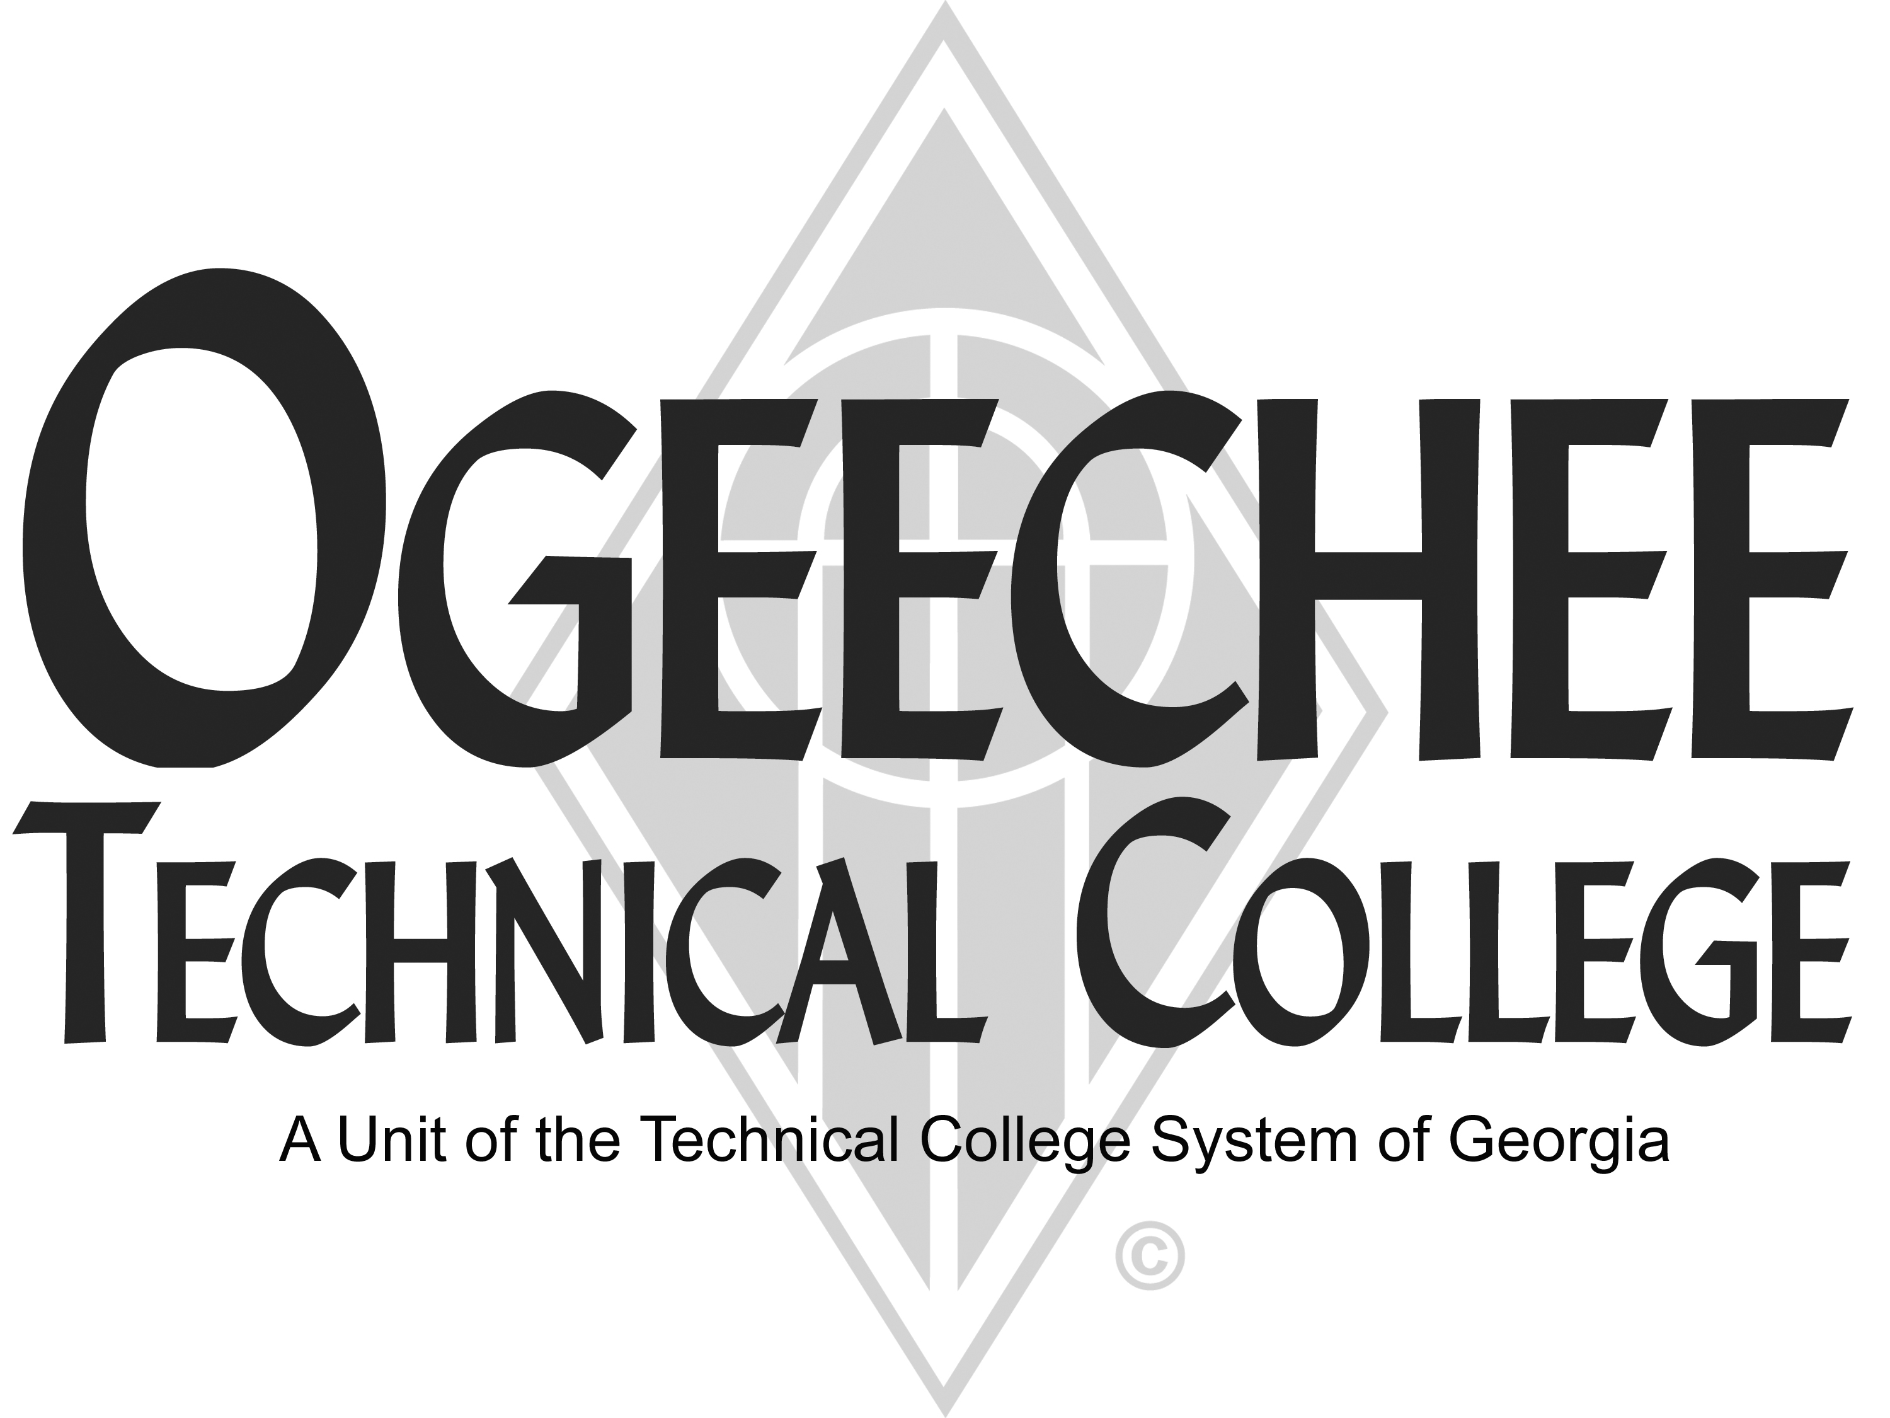
POSITION ANNOUNCEMENT(S)
POSITION TITLE: | Emergency Medical Technician (EMT) Lab Assistant
POSITION DESCRIPTION:
Under general supervision, assist EMT instructor with the teaching of EMT lab skills. Evaluates students' progress according to the required skills evaluation requirements. Maintain orderly lab facilities with supplies and equipment. Ensures safety and security requirements are met in the training area.

Minimum Qualifications
- Candidate must have a current Georgia licensure as an EMT-Intermediate or higher licensure
- Work experience in a health related, direct patient-care position for 1-3 years
- CPR certified
- Candidate must be proficient in, demonstrate, and assess current EMT skills

Preferred Qualifications
- 1-3 years in-field experience with Emergency Medical Services as an EMT, Intermediate or higher
- Georgia Level EMS Instructor License
- BLS certification as a CPR instructor
- Excellent human-relations, interpersonal skills, and strong verbal and written communication skills
SALARY/BENEFITS:
Commensurate with Qualifications

APPLICATION DEADLINE:
Open Until Filled

TO APPLY: Please submit an online application using the OTC online job center website. All positions require a pre-employment criminal background investigation, education, and employer/professional reference checks. Some positions may additionally require a motor vehicle record search, credit history check, and/or drug screen. All male applicants between the ages of 18 and 26 years of age must present proof of Selective Service Registration. Copies of all transcripts should be submitted at the time of application for faculty positions. Official transcripts are required upon employment. For more information, please contact the Director for Human Resources at 912.871.1801 or employment@ogeecheetech.edu.

The following individuals have been designated to handle inquiries regarding the non-discrimination policies: For Title IX: Christy Rikard, Office: 198C, Phone: 912.486.7607, crikard@ogeecheetech.edu. For ADA/Section 504: Sabrina Burns, Disability and Student
Support Services Coordinator, Office: 189, Phone: 912.486.7211, sburns@ogeecheetech.edu.
As set forth in its student catalog, Ogeechee Technical College does not discriminate on the basis of race, color, creed, national or ethnic origin, gender, religion, disability, age, political affiliation or belief, genetic information, veteran status, or citizenship status (except in those special circumstances permitted or mandated by law). The following individuals have been designated to handle inquiries regarding the nondiscrimination policies: Christy Rikard, Ogeechee Technical College One Joseph E. Kennedy Blvd., Office 191, Joseph E. Kennedy Building, Statesboro, GA 30458, 912.486-7607, crikard@ogeecheetech.edu and Sabrina Burns, ADA/Section 504 Coordinator, Ogeechee Technical College, One Joseph E. Kennedy Blvd., Office 189, Joseph E. Kennedy Building, Statesboro, GA 30458, 912.486.7211, sburns@ogeecheetech.edu

