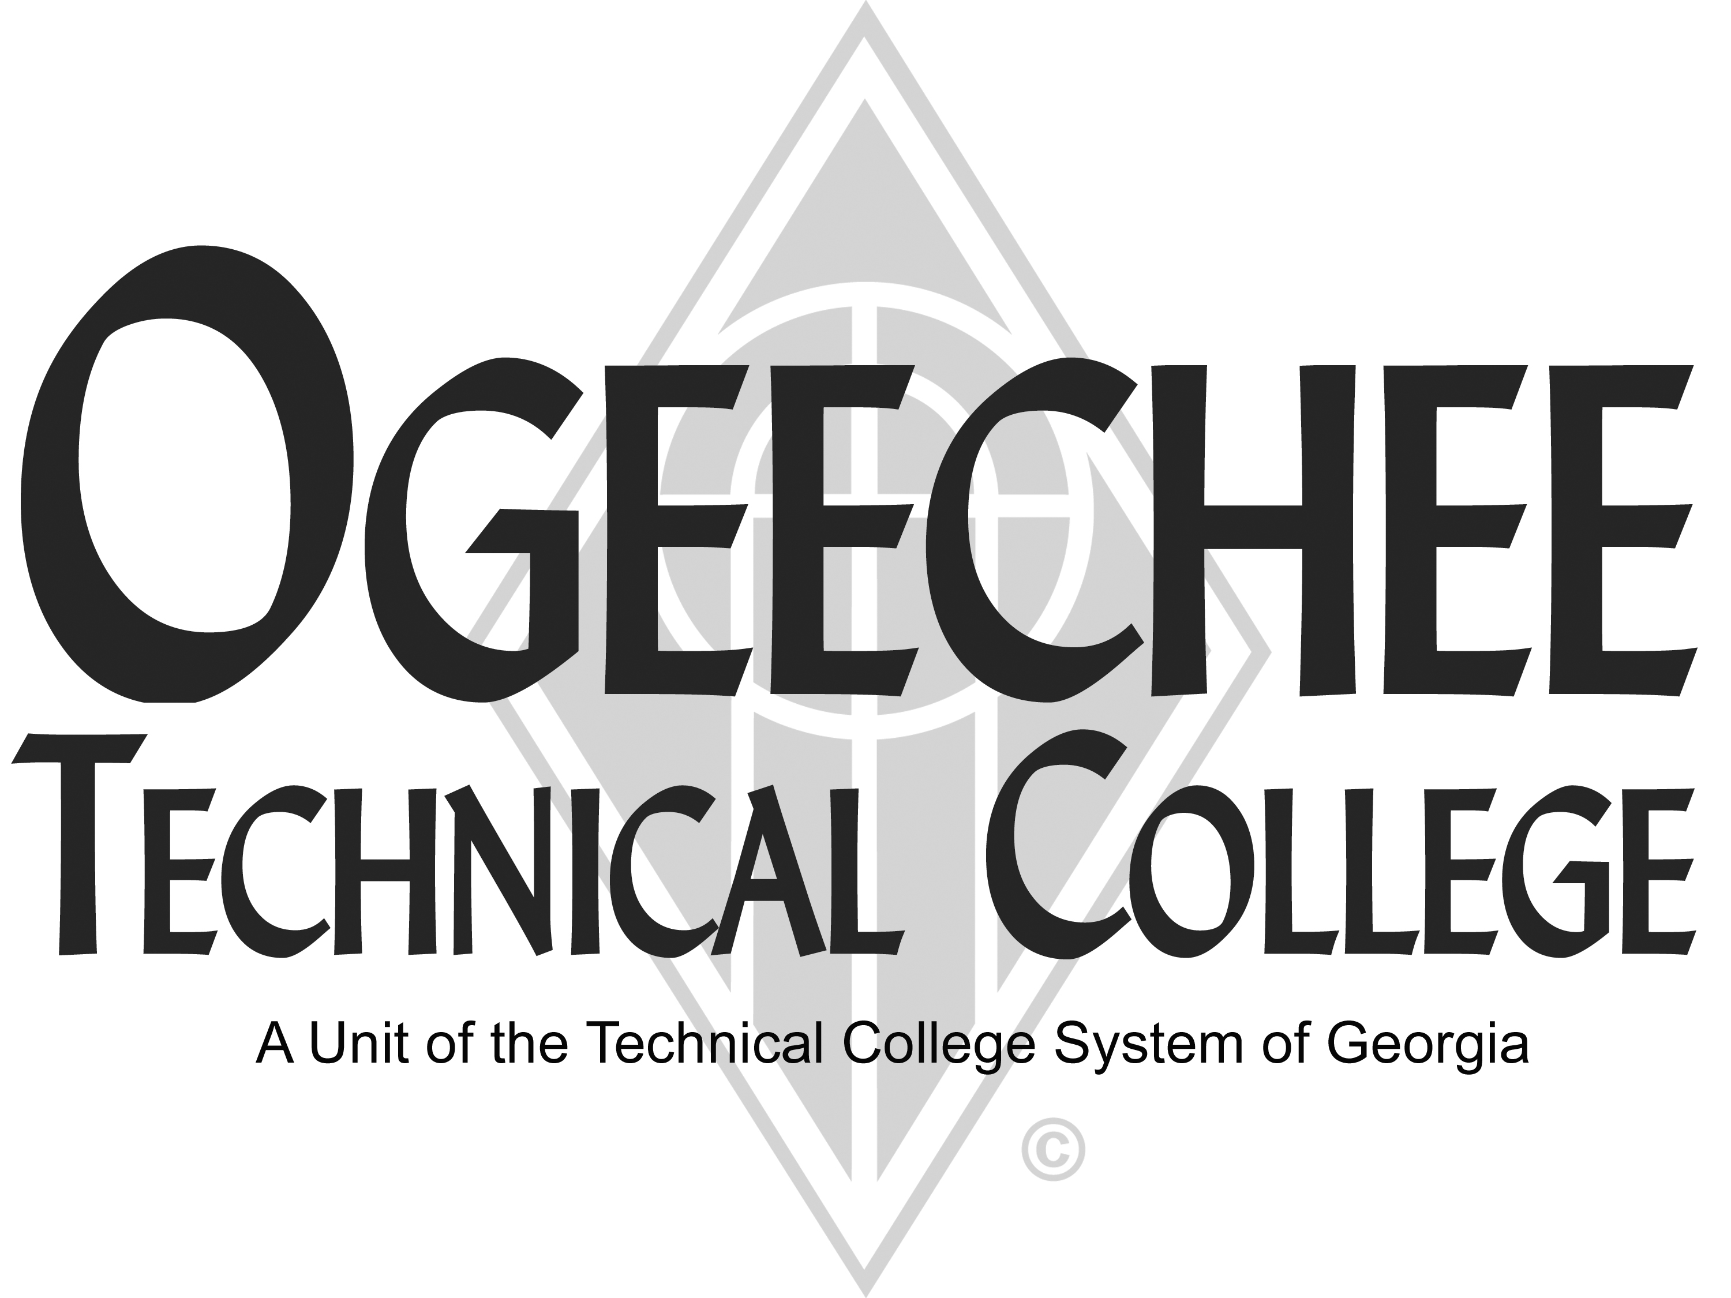
POSITION ANNOUNCEMENT
POSITION TITLE: | Part-Time Industrial Forklift Instructor – Continuing Education
POSITION DESCRIPTION:
The Industrial Forklift Continuing Education Instructor is responsible for non-credit classroom instruction providing the expertise and knowledge that supports the college curriculum and programs. Establish courses following accepted Forklift Operator training standards. Teach students using a variety of effective methodologies and provide engagement and support activities that encourage student learning.

Instruction will occur on the campus of the college. The position is on an as needed basis with the work schedule based on business needs. The successful applicant must have a flexible schedule. In addition, the instructor will be expected to interact with students, promote safety, produce reports and documents as requested, serve as a subject matter expert, and participate in institutional activities as scheduling will allow.

MAJOR DUTIES

- Comply with OSHA standard 1910.178 requirements for forklift operations by instructing and ensuring safe operational mechanics, identifying workplace hazards, proper equipment inspection procedures, safe maneuvering techniques, and emergency response protocols;
- Familiar with required OSHA standards for Forklift Operation including PPE, fall protection, age requirements, load manipulations, spatial awareness, speed control, and equipment inspections;
- Demonstrate skill and/or knowledge in teaching discipline and prepares instructional materials for classroom use;
- Conduct hands-on performance evaluations by assessing operators in real-world scenarios like load balancing, load handling, emergency response, and work specific hazards;
- Evaluates students’ ongoing progress and performance in attaining goals and objectives while providing proper recordkeeping, reports, and forms by the appropriate deadlines;
- Maintains program certification requirements;
- Maintains a secure classroom environment;
- Maintains a professional relationship with students, colleagues, and the community;
- Participates in activities required to maintain program and college accreditation standards as necessary; and
- Other duties as assigned.

COMPETENCIES

- Skill in oral and written communication
- Skill in interpersonal relations
- Ability to adapt instructional material to fit all learning styles
- Ability to maintain accurate records
- Knowledge of effective instructional methods for adult learners

MINIMUM QUALIFICATIONS:
- High school diploma or equivalent *and* (3) years of experience in an Industrial Forklift Training position or a related field.
PREFERRED QUALIFICATIONS:
- OSHA knowledge and/or certifications
SALARY/BENEFITS:
Commensurate with qualifications. Benefits include paid state holidays, annual and sick leave, retirement options, and State of Georgia Flexible Benefits package.

APPLICATION DEADLINE:
Open Until Filled
TO APPLY: Please submit an online application using the OTC online job center website. All positions require a pre-employment criminal background investigation, education, and employer/professional reference checks. Some positions may additionally require a motor vehicle record search, credit history check, and/or drug screen. All male applicants between the ages of 18 and 26 years of age must present proof of Selective Service Registration. Copies of all transcripts should be submitted at the time of application for faculty positions. Official transcripts are required upon employment. For more information, please contact the Director for Human Resources at 912.871.1801 or employment@ogeecheetech.edu.
Ogeechee Technical College does not discriminate on the basis of race, color, creed, national or ethnic origin, sex, religion, disability, age, political affiliation or belief, genetic information, disabled veteran, veteran of the Vietnam Era, spouse of military member or citizenship status (except in those special circumstances permitted or mandated by law). The following individuals have been designated to handle inquiries regarding the nondiscrimination policies: Christy Rikard, Ogeechee Technical College One Joseph E. Kennedy Blvd., Office 198C, Joseph E. Kennedy Building, Statesboro, GA 30458, 912.486.7607, crikard@ogeecheetech.edu and Sabrina Burns, ADA/Section 504 Coordinator, Ogeechee Technical College, One Joseph E. Kennedy Blvd., Office 189, Joseph E. Kennedy Building, Statesboro, GA 30458, 912.486.7211, sburns@ogeecheetech.edu.

