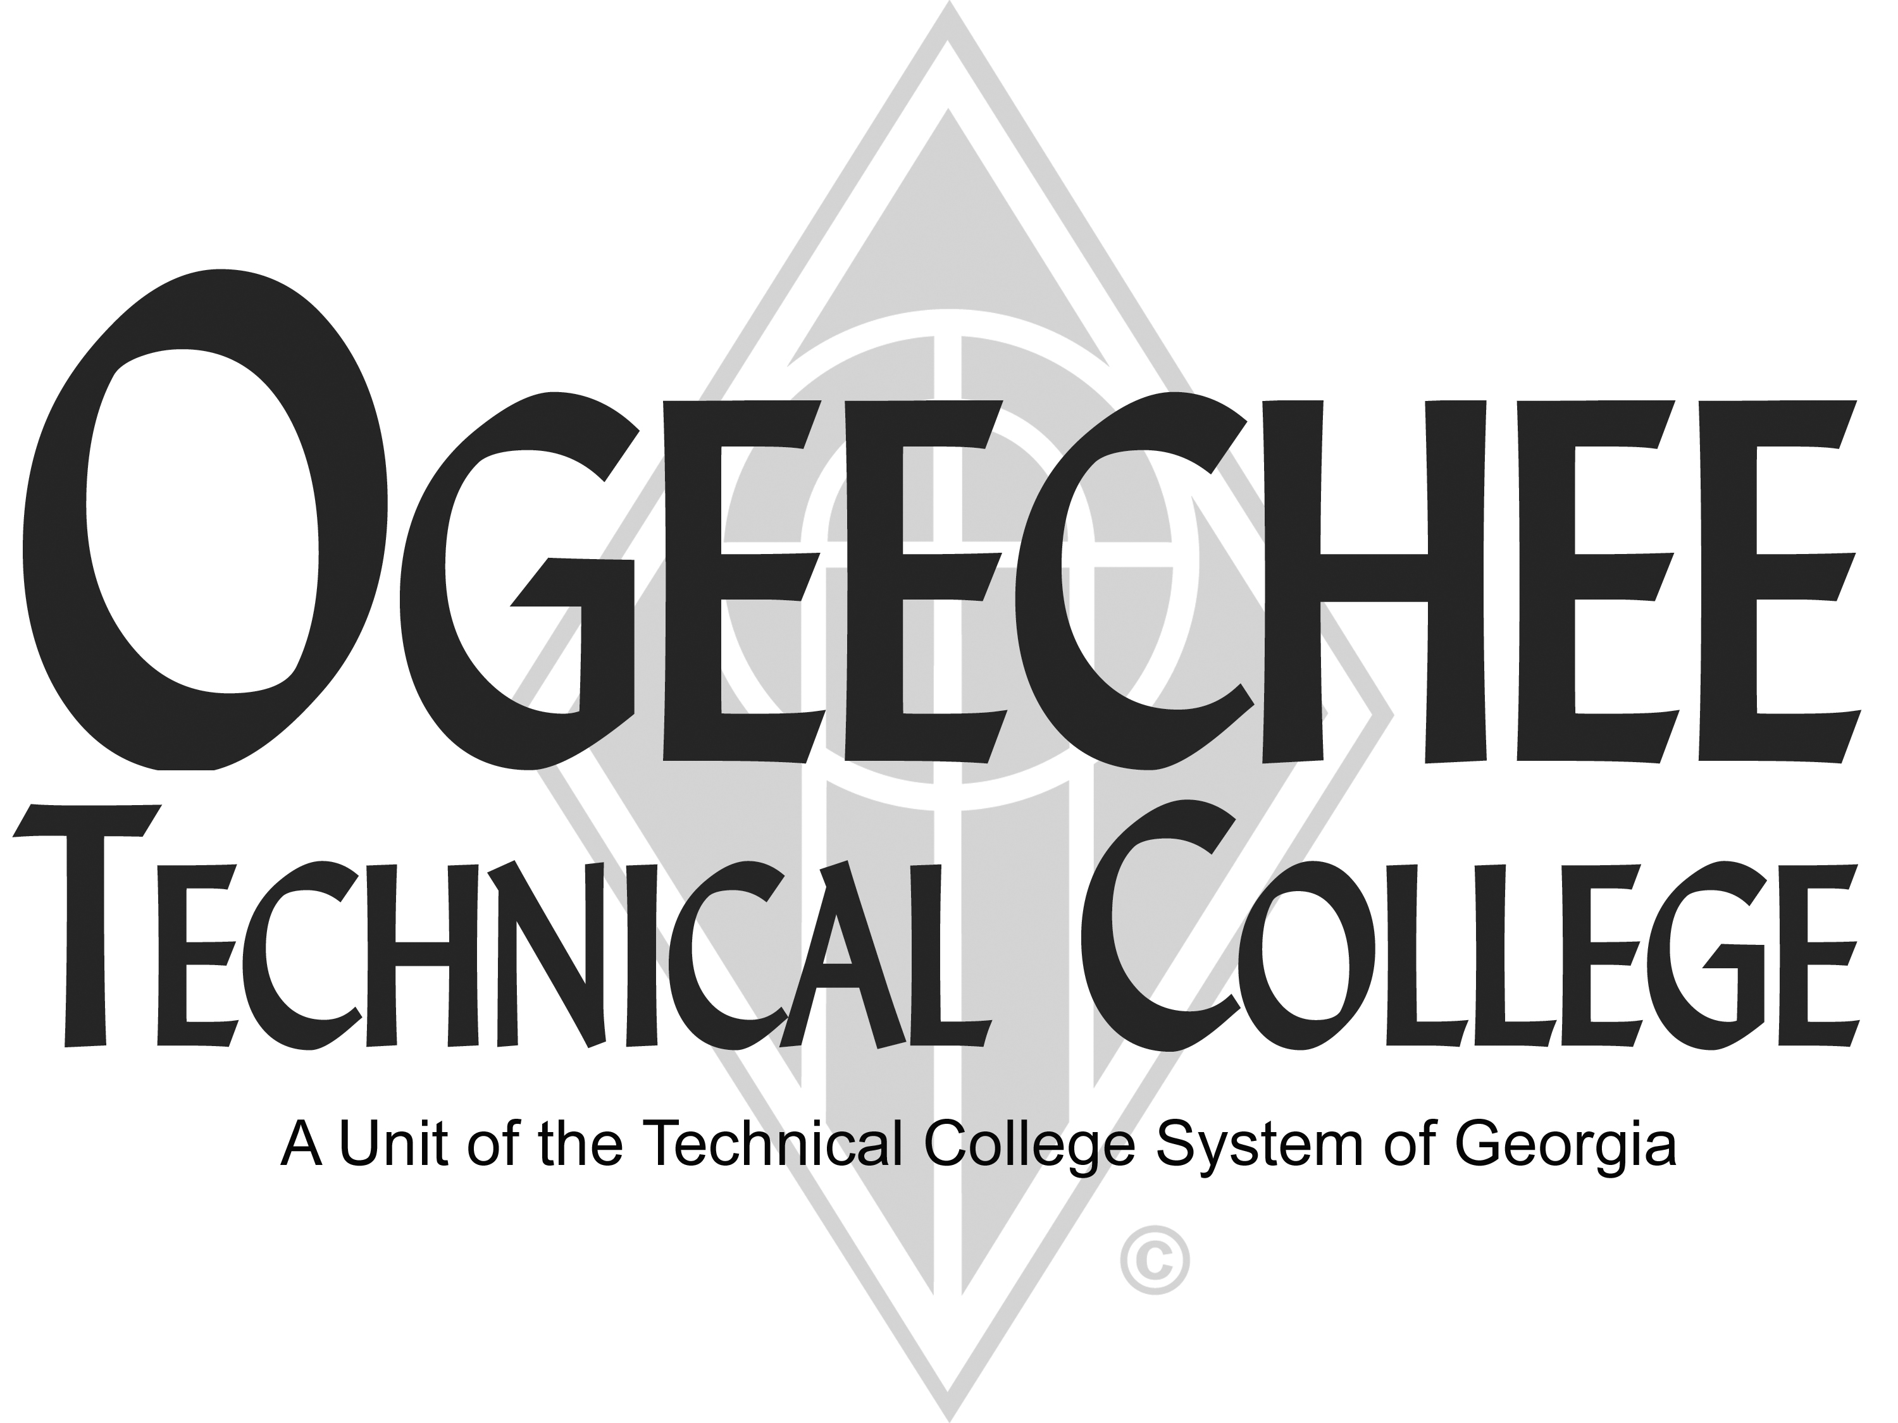
POSITION ANNOUNCEMENT
POSITION TITLE: | Industrial Systems Instructor – Continuing Education
POSITION DESCRIPTION:
The Industrial Systems Continuing Education Instructor is responsible for non-credit classroom instruction in industrial systems maintenance and evaluating students’ progress in attaining goals and objectives.

Under minimal supervision, the Industrial systems Instructor is responsible for the delivery of rigorous short-term, non-credit training programs in Industrial Systems including: theory and practical applications, DC and AC drives, process control systems, motor controls, mechanical drives, pneumatics, hydraulics, PLC, troubleshooting, administering assessments, and delivering customized training programs.

Instruction will occur on the campus of the college. The position is Monday through Friday. The successful applicant must have a flexible schedule. In addition, the instructor will be expected to interact with students, maintain lab equipment and safety, produce reports and documents as requested, serve as a subject matter expert, and participate in institutional activities as scheduling will allow. This is a full-time position.

Will need to obtain appropriate SACA certifications within three months of being hired.

MAJOR DUTIES

- Prepares instructional materials for classroom use;
- Evaluates students’ ongoing progress and performance in attaining goals and objectives;
- Maintains supplies and equipment;
- Maintains program certification requirements;
- Maintains a secure classroom environment;
- Ensures safety and security requirements are met in the training area; and
- Other duties as assigned.

COMPETENCIES

- Skill in oral and written communication
- Skill in interpersonal relations
- Ability to adapt instructional material to fit all learning styles
- Ability to maintain accurate records
- Knowledge of effective instructional methods for adult learners

MINIMUM QUALIFICATIONS:
- Minimum qualifications for this position are (3) years of experience in industrial maintenance or a related field.
PREFERRED QUALIFICATIONS:
- Three (3) or more years of experience teaching or training in industrial maintenance and industrial systems.
SALARY/BENEFITS:
Commensurate with qualifications. Benefits include paid state holidays, annual and sick leave, retirement options, and State of Georgia Flexible Benefits package.

APPLICATION DEADLINE:
Open Until Filled
TO APPLY: Please submit an online application using the OTC online job center website. All positions require a pre-employment criminal background investigation, education, and employer/professional reference checks. Some positions may additionally require a motor vehicle record search, credit history check, and/or drug screen. All male applicants between the ages of 18 and 26 years of age must present proof of Selective Service Registration. Copies of all transcripts should be submitted at the time of application for faculty positions. Official transcripts are required upon employment. For more information, please contact the Director for Human Resources at 912.871.1801 or employment@ogeecheetech.edu.
Ogeechee Technical College does not discriminate on the basis of race, color, creed, national or ethnic origin, sex, religion, disability, age, political affiliation or belief, genetic information, disabled veteran, veteran of the Vietnam Era, spouse of military member or citizenship status (except in those special circumstances permitted or mandated by law). The following individuals have been designated to handle inquiries regarding the nondiscrimination policies: Christy Rikard, Ogeechee Technical College One Joseph E. Kennedy Blvd., Office 198C, Joseph E. Kennedy Building, Statesboro, GA 30458, 912.486.7607, crikard@ogeecheetech.edu and Sabrina Burns, ADA/Section 504 Coordinator, Ogeechee Technical College, One Joseph E. Kennedy Blvd., Office 189, Joseph E. Kennedy Building, Statesboro, GA 30458, 912.486.7211, sburns@ogeecheetech.edu.

