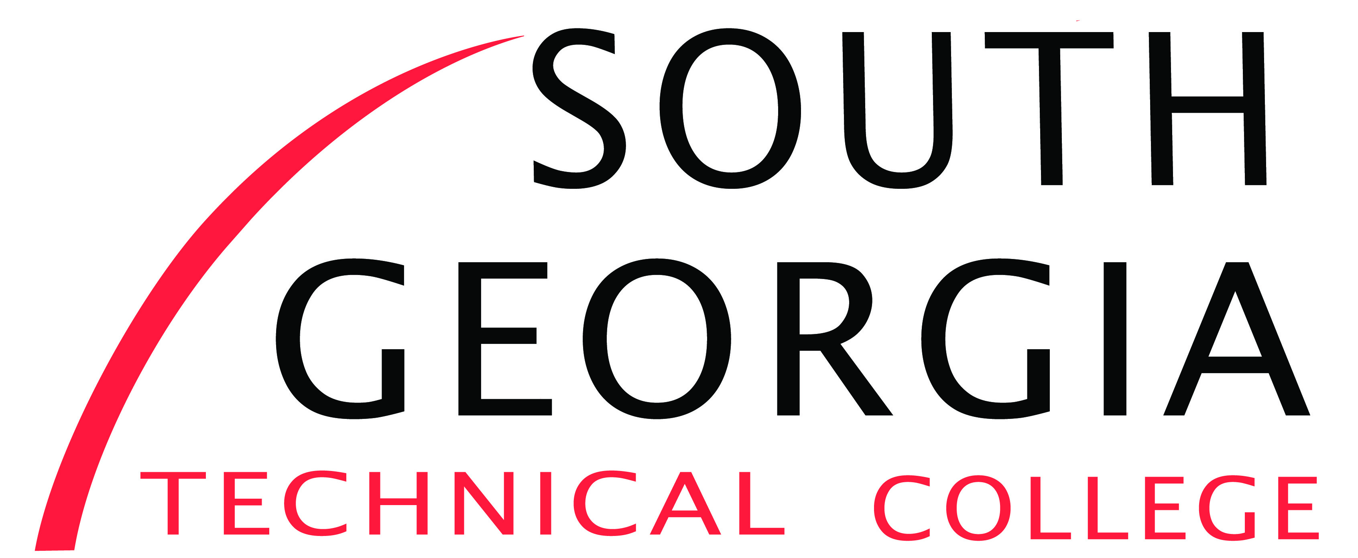

Human Resources
900 South GA Tech Pkwy
Americus, GA 31709
229-931-2450

Basic Heavy Equipment Operator Adjunct Instructor

Campus: Americus or Cordele
Perform all teaching duties of Heavy Equipment Operator Instructor program courses. Possess strong written and verbal communication skills. Demonstrate competencies, knowledge and skills in diesel or heavy equipment profession. SGTC’s Heavy Equipment program is a leading provider of heavy equipment education training due to its outstanding faculty, industry partnerships, co-op opportunities and state of the art facilities. Some travel is required; valid driver’s license. Work flexible schedule, including some evening and weekend assignments, may be required.
Instructor is expected to:
- Stay current in subject matter through professional development/training
- Plan and organize instruction in ways that maximize student learning,
- Serve on college, divisional and program committees; participate in meeting and events as required
- Contribute to program and division curriculum development process.
- Other duties as assigned.

Minimum Qualifications: Associate’s Degree from a regionally college/university in the discipline or related field and a minimum of five (5) years Diesel/Heavy Equipment experience. Must be student oriented and customer friendly. Excellent communication and interpersonal skills with faculty, staff and business/industry. Ability to perform tasks unsupervised and excellent time management skills

Preferred Qualifications: Previous instructional experience with post-secondary education or industry. Bachelor’s degree from a regionally accredited college/university.

Physical demands: Work is typically performed in a classroom with intermittent sitting or walking in various settings. Must frequently lift and carry lightweight objects. Full range of hand and finger motion is required. The ability to speak clearly is required. The ability to hear and understand at a normal conversational level is required.
Salary/Benefits: Hourly Rate commensurate with education and work experience. All adjunct positions are part-time temporary, less than 25 hours per week, based on student enrollment each term, and do not include benefits or a promise of future full-time employment.

Position Available: Immediately

Applicant Instructions/Information: Please complete our SGTC application on our website www.southgatech.edu; access this by clicking on the link Careers @ SGTC. For further assistance call the Human Resources Office at (229) 931-2454 or (229) 931-2450 or by emailing Erika.Carrillo@southgatech.edu or Suzanne.Singletary@southgatech.edu. Pursuant to college policy, a thorough background investigation, including a criminal history check, shall be conducted on all candidates prior to being hired for any position with SGTC.

Equal Opportunity Employer.
As set forth in its student catalog, South Georgia Technical College does not discriminate on the basis of race, color, creed, national or ethnic origin, sex, religion, disability, age, political affiliation or belief, genetic information, veteran status, or citizenship status (except in those special circumstances permitted or mandated by law). The following person(s) has been designated to handle inquiries regarding the non-discrimination policies: Title IX Coordinator Eulish Kinchens, 229-931-2249, ekinchens@southgatech.edu, or Section 504/ADA Coordinator, Jennifer Robinson 229-931-2595 Jennifer.Robinson@outhgatech.edu

