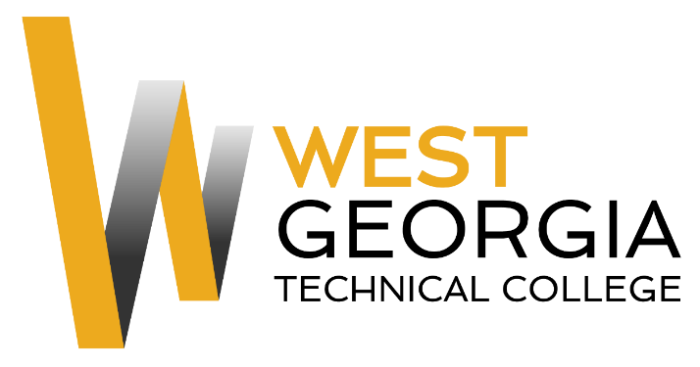
Job Announcement

Position: Federal Work Study/Student Worker
Location: Carroll Campus
Department: Maintenance
Reports to: Michael Warner
Nature of Duties: The Federal Work Study will assist maintenance personnel with various, general maintenance projects to include light construction, painting, mechanical work, medium size electrical work, changing light bulbs, light plumbing including restroom repair, equipment repair and use of power tools.
Minimum Qualifications:
- Be enrolled as a student at West Georgia Technical College
- Completed a FAFSA and be identified as being eligible for federal aid
- Complete a Federal Work-Study Employment Application available on-line at: WGTC Job Center-Student Employment

Preferred Qualifications:
- Familiarity with power tools
- Basic knowledge of HVAC and sanitation
- Security experience
- Ability to lift (up to 20lbs), bend and stoop on a regular basis
- Organizational skills
- Ability to take and follow direction from supervisor
- Ability to break larger tasks into manageable smaller tasks;

Salary/Benefits: $10.00 per hour; no benefits
Method of Application: Interested candidates must complete electronic application process at WGTC Job Center-Student Employment Student Worker will be contacted by Supervisor for interviews.
Employment Policy: The Technical College System of Georgia and West Georgia Technical College do not discriminate on the basis of race, color, creed, national or ethnic origin, gender, religion, disability, age, political affiliation or belief, disabled veteran, veteran of the Vietnam Era, or citizenship status (except in those special circumstances permitted or mandated by law) in educational programs, activities, admissions or employment. All applicants will be considered; however, only selected applicants may be interviewed. Approval of employment does not constitute a contract. Continued employment is contingent upon job performance and funding.

