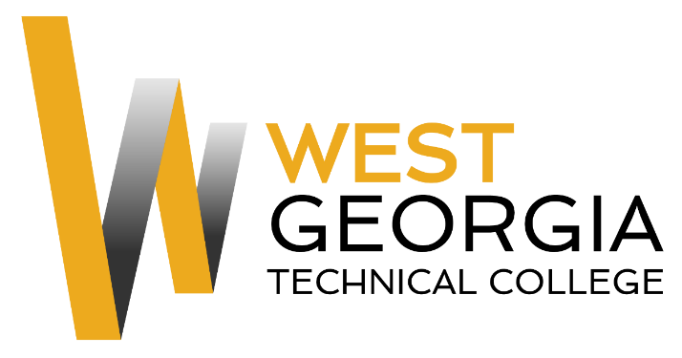
Job Announcement

Position: Federal Work Study/Student Worker
Location: Coweta Campus
Department: Information Technology
Reports to: Technical Support Specialist
Nature of Duties: The Federal Work Study will assist with software or hardware problems when able to do so, or refer users to specified technical support personnel for help. Help keep the computer labs organized and tidy. Greet students, answer the telephone, retrieve and open mail, shred documents, make copies, scan documents, file, keep printers and copiers stocked and other duties as assigned.
Minimum Qualifications:
- Be enrolled as a student at West Georgia Technical College
- Completed a FAFSA and be identified as being eligible for federal aid
- Complete a Federal Work-Study Employment Application available on-line at: WGTC Job Center-Student Employment

Preferred Qualifications:
- Possess knowledge of cabling and troubleshooting computer hardware and software problems/imaging computers
- Organizational skills
- Oral and written communication skills
- Ability to take and follow direction from supervisor
- Ability to demonstrate proper phone techniques and etiquette with the ability to multi-task
- Proficient use of Microsoft Word, Excel, and Outlook
- Experience working with customers on the phone, via e-mail, and in person
- Ability to lift (up to 20lbs), bend and stoop on a regular basis
- Ability to break larger tasks into manageable smaller tasks;

Salary/Benefits: $10.00 per hour; no benefits
Method of Application: Interested candidates must complete electronic application process at WGTC Job Center-Student Employment Student Worker will be contacted by Supervisor for interviews.
Employment Policy: The Technical College System of Georgia and West Georgia Technical College do not discriminate on the basis of race, color, creed, national or ethnic origin, gender, religion, disability, age, political affiliation or belief, disabled veteran, veteran of the Vietnam Era, or citizenship status (except in those special circumstances permitted or mandated by law) in educational programs, activities, admissions or employment. All applicants will be considered; however, only selected applicants may be interviewed. Approval of employment does not constitute a contract. Continued employment is contingent upon job performance and funding.

