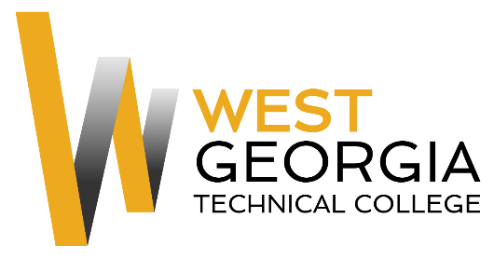

Job Announcement

Position: Federal Work Study
Location: Murphy Campus, Waco, GA
Department: Human Resources
Reports to: HR Manager
Nature of Duties: The Federal Work Study will provide aid to the Human Resources Department by performing general clerical duties including filing and other duties as assigned.
Minimum Qualifications:
- Satisfactorily enrolled as a student at West Georgia Technical College
- Ability to lift 20 lbs., bend and stoop on a regular basis
- Completed a FAFSA and be identified as being eligible for federal aid
- Complete a Federal Work-Study Employment Application available on-line at: WGTC Job Center-Student Employment

Preferred Qualifications:

- Excellent customer service skills
- High level of detail orientation
- Proficient use of Microsoft Word, Excel, and Visio
- Experience working with customers on the phone, via e-mail, and in person
- Previous HR experience a plus

Salary/Benefits: $10 per hour; no benefits.
Method of Application: Interested candidates must complete electronic application process at WGTC Job Center-Student Employment Student Worker will be contacted by Supervisor for interviews.
Employment Policy: The Technical College System of Georgia and West Georgia Technical College do not discriminate on the basis of race, color, creed, national or ethnic origin, gender, religion, disability, age, political affiliation or belief, disabled veteran, veteran of the Vietnam Era, or citizenship status (except in those special circumstances permitted or mandated by law) in educational programs, activities, admissions or employment. All applicants will be considered; however, only selected applicants may be interviewed. Approval of employment does not constitute a contract. Continued employment is contingent upon job performance and funding.

