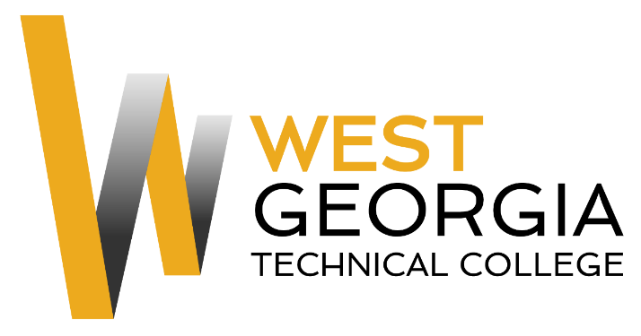
Job Announcement

Position: Federal Work Study
Location: Coweta Campus
Department: Maintenance
Reports to: Keith Basinger
Nature of Duties: The Federal Work Study will assist maintenance personnel with various, general maintenance projects as needed following safety procedures and instructions. Could include light construction, painting, mechanical work, changing light bulbs, equipment repair and use of power tools. Preferred applicant will exhibit desire to help and learn new things with a positive, can-do attitude.
Minimum Qualifications:
- Be enrolled as a student at West Georgia Technical College
- Completed a FAFSA and be identified as being eligible for federal aid
- Complete a Federal Work-Study Employment Application available on-line at: WGTC Job Center-Student Employment

Preferred Qualifications:
- Willingness to help where needed
- Open to learning new things
- Ability to lift (up to 20lbs), bend and stoop on a regular basis
- Organizational skills
- Ability to take and follow direction from supervisor
- Ability to break larger tasks into manageable smaller tasks;

Salary/Benefits: $10.00 per hour; no benefits.
Number of positions: 1
Method of Application: Interested candidates must complete electronic application process at WGTC Job Center-Student Employment Student Worker will be contacted by Supervisor for interviews.
Employment Policy: The Technical College System of Georgia and West Georgia Technical College do not discriminate on the basis of race, color, creed, national or ethnic origin, gender, religion, disability, age, political affiliation or belief, disabled veteran, veteran of the Vietnam Era, or citizenship status (except in those special circumstances permitted or mandated by law) in educational programs, activities, admissions or employment. All applicants will be considered; however, only selected applicants may be interviewed. Approval of employment does not constitute a contract. Continued employment is contingent upon job performance and funding.

