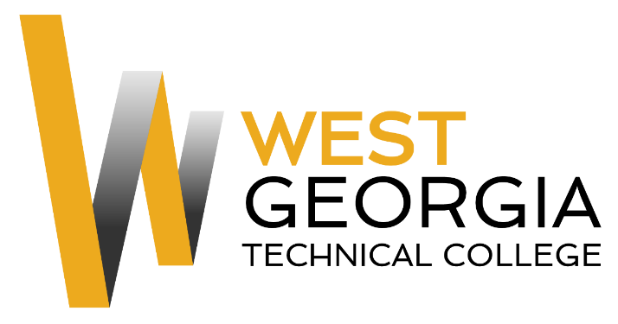
Job Announcement

Position: Federal Work Study/Student Worker
Location: Murphy Campus
Department: NAST 1100 Lab Assistant
Reports to: Abby Sutton
Nature of Duties: The Federal Work Study will assist with organization of records, data entry, maintain lab equipment, making copies, clerical work as assigned, keeping clinical lab neat/clean and supplies organized.

Minimum Qualifications:
- Be enrolled as a student at West Georgia Technical College
- Completed a FAFSA and be identified as being eligible for federal aid
- Complete a Federal Work-Study Employment Application available on-line at: WGTC Job Center-Student Employment

Preferred Qualifications:
- Ability to keep lab and supplies clean
- Organizational skills
- Ability to take and follow direction from supervisor
- Proficient use of Microsoft Word, Excel, and Outlook
- Ability to lift (up to 20lbs), bend and stoop on a regular basis
- Ability to break larger tasks into manageable smaller tasks;

Salary/Benefits: $10.00 per hour; no benefits
Method of Application: Interested candidates must complete electronic application process at WGTC Job Center-Student Employment Student Worker will be contacted by Supervisor for interviews.
Employment Policy: The Technical College System of Georgia and West Georgia Technical College do not discriminate on the basis of race, color, creed, national or ethnic origin, gender, religion, disability, age, political affiliation or belief, disabled veteran, veteran of the Vietnam Era, or citizenship status (except in those special circumstances permitted or mandated by law) in educational programs, activities, admissions or employment. All applicants will be considered; however, only selected applicants may be interviewed. Approval of employment does not constitute a contract. Continued employment is contingent upon job performance and funding.

