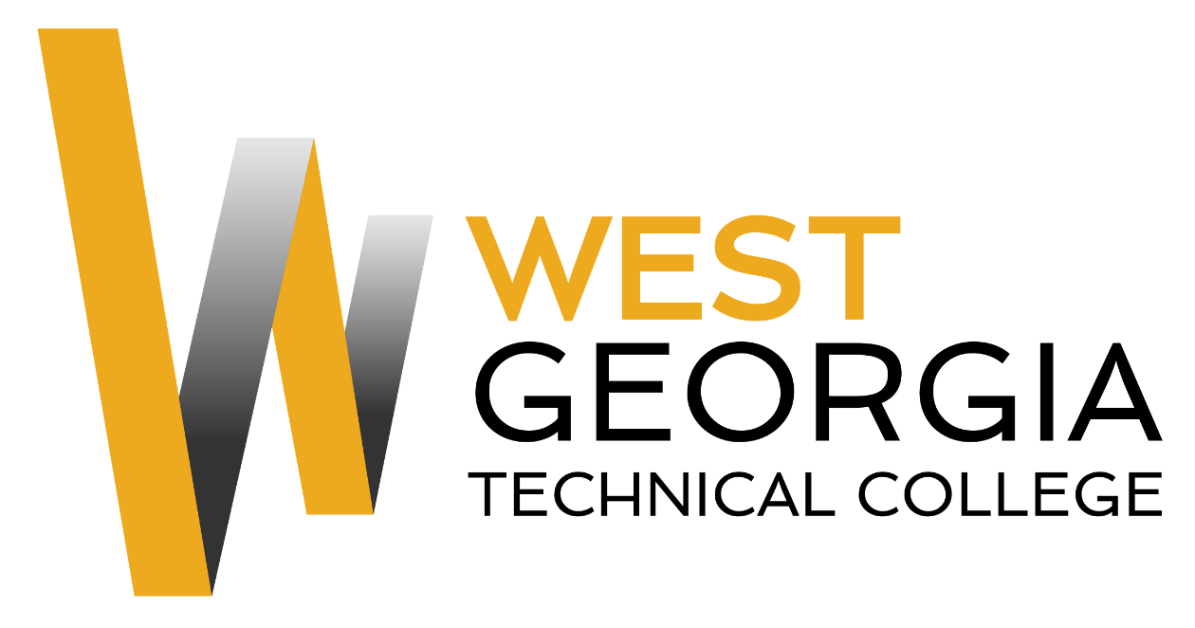

Position: Temporary Adjunct
Location: Murphy Campus
Department: Academic Affairs
Reports to: Associate Dean
Nature of Duties: Under general supervision prepares lesson plans for classroom instruction for credited technical/occupational courses; develops program curriculum, syllabi, goals, and objectives; evaluates students’ progress in attaining goals and objectives. Requests and maintains supplies and equipment; maintains program certification/accreditation requirements as appropriate. Prepares and maintains all required documentation and administrative reports; ensures safety and security requirements are met in the discipline area; meets with students, staff members and other educators to discuss students’ instructional programs and other issues; assists with recruitment, retention, and job placement efforts. Teaches in a classroom/lab/field environment that closely simulates the environment of the industry while maintaining knowledge of current trends and developments in the field. Provides instruction in the theory and practical applications of related subject; establishes, measures, and evaluates program or departmental student learning outcomes for continuous student improvement and success. Requires strong computer skills, communication skills, and ability to interact effectively with a diverse student population. Position may require committee and project assignments or other duties as assigned as well as day/evening/distance learning classes and activities.

Minimum and Preferred Qualifications will vary dependent upon teaching discipline.

Salary/Benefits: Salary based upon qualifications. No benefits.
Method of Application: Interested candidates should apply through electronic application system at: WGTC Job Center. Unofficial Transcripts, resume, and proof of applicable certifications\licensure are required for consideration. Official transcripts and prior employment verification required within 30 days of hire for continuous employment.
Please Note: If hired for a temporary adjunct position, such employment will be valid for one semester only. For consideration for a full time or regular adjunct position, you must apply for a specific job posting on the WGTC Job Center.
Employment Policy: The Technical College System of Georgia and West Georgia Technical College do not discriminate on the basis of race, color, creed, national or ethnic origin, gender, religion, disability, age, political affiliation or belief, disabled veteran, veteran of the Vietnam Era, or citizenship status (except in those special circumstances permitted or mandated by law) in educational programs, activities, admissions or employment. All applicants will be considered; however, only selected applicants may be interviewed. Approval of employment does not constitute a contract. Continued employment is contingent upon job performance and funding.

