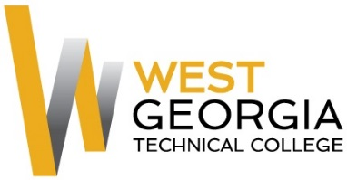

Job Announcement

Position: WIOA Program Specialist
Location: Murphy
Department: Student Affairs
Reports to: Manager Career & Student Support
FLSA Designation: Non-exempt

Nature of Duties: Under general supervision, the Program Specialist provides specialized guidance, day-to-day technical management and expertise over an assigned program.

Job duties include, but are not limited to:
- Provides program technical assistance to staff,students/participants, faculty, administrators and other customers in relation to program/operational area
- Performs programmatic/operational functions for the assigned program
- Monitors participant/student work and progress
- Generates reports regarding program activity
- Maintains supplies and equipment
- Greet customers and ensure that appropriate information is provided
- Shares knowledge of services of the One Stop partners and other community resources
- Knowledge of all available resource materials
- Assist customers with job search and interview preparation process
- Other duties as assigned

Competencies
- Oral and written communication skills
- Decision making and problem solving skills
- Skill in the operation of computers and job related software programs
- Skill in interpersonal relations and in dealing with the public
- Knowledge of current industry trends and technology

Minimum Qualifications:
- Associate’s degree in a course of study related to the occupational field *and* Three (3) years of related work experience

Preferred Qualifications:
- Experience with resume preparation and job search skills
- Knowledge of WIOA policies, procedures, regulations and guidelines

Salary/Benefits: High 27,500; Benefits include paid state holidays, vacation, retirement, personal and sick leave, and the State of Georgia Flexible Benefits Program.

Method of Application: Interested candidates should apply through electronic application system at: WGTC Job Center

Employment Policy
The Technical College System of Georgia and West Georgia Technical College do not discriminate on the basis of race, color, creed, national or ethnic origin, gender, religion, disability, age, political affiliation or belief, disabled veteran, veteran of the Vietnam Era, or citizenship status (except in those special circumstances permitted or mandated by law) in educational programs, activities, admissions or employment. All applicants will be considered; however, only selected applicants may be interviewed. Approval of employment does not constitute a contract. Continued employment is contingent upon job performance and funding.

Notes
- Unofficial Transcripts, resume, and proof of applicable certifications\licensure are required for consideration. Official transcripts and prior employment verification required within 30 days of hire for continuous employment.
- Selected candidate must successfully complete a background check to include employment references, criminal history, and verification of employment prior to hire.
- West Georgia Technical College is not currently sponsoring work visas at this time.
- This position is not eligible for relocation assistance.

