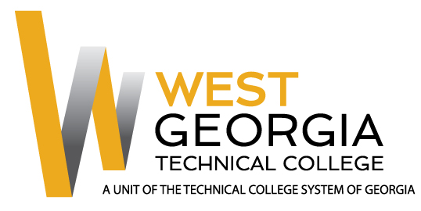
Job Announcement

Position: Welding and Joining Technology Adjunct Instructor
Location: CEC – Newnan, Ga.
Department: Academic Affairs
Reports to: Associate Dean of Trade & Technology

FLSA Designation: Non-Exempt; Adjunct Instructor
Nature of Duties: Under general supervision prepares lesson plans for classroom instruction for credited technical/occupational courses; develops program curriculum, syllabi, goals, and objectives; evaluates students’ progress in attaining goals and objectives. Requests and maintains supplies and equipment and prepares budget requests; maintains program certification/accreditation requirements as appropriate. Prepares and maintains all required documentation and administrative reports; attends professional development training, workshops, seminars, and conferences; ensures safety and security requirements are met in the discipline area; meets with students, staff members and other educators to discuss students’ instructional programs and other issues; assists with recruitment, retention, and job placement efforts. Teaches courses in welding technology in a classroom/lab/field environment that closely simulates the environment of the industry while maintaining knowledge of current trends and developments in the field. Provides instruction in the theory and practical applications of welding; establishes, measures, and evaluates program or departmental student learning outcomes for continuous student improvement and success. Requires strong computer skills, communication skills, and ability to interact effectively with a diverse student population. Position may require committee and project assignments or other duties as assigned as well as day/evening classes and activities. Successful completion of (2) specified AWS welding tests is a condition of employment.

Minimum Qualifications: (candidates must meet all minimum qualifications to be considered)
- Diploma in Welding & Joining Technology or a related field from an accredited institution
- Three (3) years out of the past seven (7) years of experience in-field
- Valid Driver’s License
Preferred Qualifications:
- Associate’s Degree in Welding & Joining Technology from an accredited institution
- Directly related teaching experience at the postsecondary level
- AWS or other related Welding Certification
Method of Application: Interested candidates should apply through electronic application system at: WGTC Job Center

Employment Policy
The Technical College System of Georgia and West Georgia Technical College do not discriminate on the basis of race, color, creed, national or ethnic origin, gender, religion, disability, age, political affiliation or belief, disabled veteran, veteran of the Vietnam Era, or citizenship status (except in those special circumstances permitted or mandated by law) in educational programs, activities, admissions or employment. All applicants will be considered; however, only selected applicants may be interviewed. Approval of employment does not constitute a contract. Continued employment is contingent upon job performance and funding.

Notes
- Unofficial Transcripts, resume, and proof of applicable certifications\licensure are required for consideration. Official transcripts and prior employment verification required within 30 days of hire for continuous employment.
- Selected candidate must successfully complete a background check to include employment references, criminal history, and verification of employment prior to hire.
- West Georgia Technical College is not currently sponsoring work visas at this time.
- This position is not eligible for relocation assistance.

