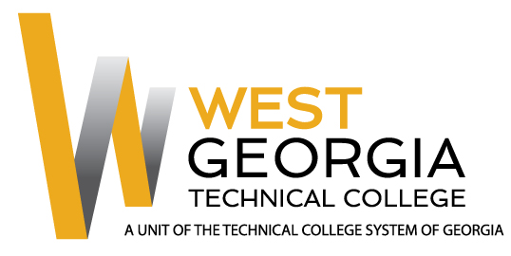

Job Announcement

Position: Precision Manufacturing and Maintenance Instructor - adjunct
Location: Carroll Campus – Carrollton, GA
Department: School of Trade & Technology
Reports to: Associate Dean, Trade & Technology
Nature of Duties: Under general supervision prepares lesson plans for classroom instruction for credited technical/occupational courses; develops program curriculum, syllabi, goals, and objectives; evaluates students’ progress in attaining goals and objectives. Requests and maintains supplies and equipment and prepares budget requests; maintains program certification/accreditation requirements as appropriate. Prepares and maintains all required documentation and administrative reports; attends professional development training, workshops, seminars, and conferences; ensures safety and security requirements are met in the discipline area; meets with students, staff members and other educators to discuss students’ instructional programs and other issues; assists with recruitment, retention, and job placement efforts. Teaches courses in the Precision Manufacturing and Maintenance program which includes Industrial Systems and courses related to manufacturing processes. Course to be taught in a classroom/lab/field environment that closely simulates the environment of the industry while maintaining knowledge of current trends and developments in the field. Provides instruction in the theory and practical applications of Precision Manufacturing; establishes, measures, and evaluates program or departmental student learning outcomes for continuous student improvement and success. Requires strong computer skills, communication skills, and ability to interact effectively with a diverse student population. Position may require committee and project assignments or other duties as assigned as well as day/evening classes and\or classes taught at external sites.

Minimum Qualifications: (candidates must meet all minimum qualifications to be considered)
- Associate’s Degree in Industrial Systems Technology, Precision Manufacturing, or a related field such as Advanced or Industrial Manufacturing from an accredited institution
- Three (3) years out of the past seven (7) years of experience in-field
Preferred Qualifications:
- Bachelor’s Degree in Industrial Systems Technology, Manufacturing, or a related field from an accredited institution
- Directly related teaching experience at the postsecondary level
- Six-Sigma and\or other lean manufacturing or other Industry recognized in-field Certifications
Salary/Benefits: Based on qualifications. No benefits.
Method of Application: Interested candidates should apply through electronic application system at: WGTC Job Center. Unofficial Transcripts, resume, and proof of applicable certifications\licensure are required for consideration. Official transcripts and prior employment verification required within 30 days of hire for continuous employment.
Employment Policy: The Technical College System of Georgia and West Georgia Technical College do not discriminate on the basis of race, color, creed, national or ethnic origin, gender, religion, disability, age, political affiliation or belief, disabled veteran, veteran of the Vietnam Era, or citizenship status (except in those special circumstances permitted or mandated by law) in educational programs, activities, admissions or employment. All applicants will be considered; however, only selected applicants may be interviewed. Approval of employment does not constitute a contract. Continued employment is contingent upon job performance and funding.

